Revelation

**Part II – Chapters 6 thru 11[1]**

**Revelation 6**

Verses 1-17 – The First Sevenfold Vision[2]

The Six Seals: Tribulation and the End (and Its Terror)[3]

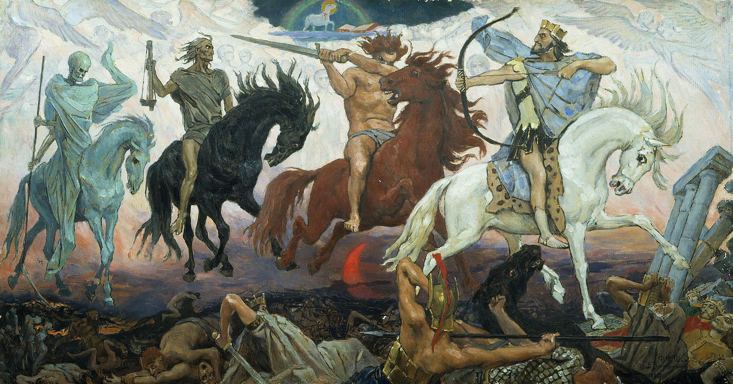

“Four Horsemen of the Apocalypse” by Victor Vasnetsov, 1887

v.1-8 – here we see the world-famous “Four Horsemen of the Apocalypse.”[4] While pop-culture sometimes gets their identities wrong,[5] Revelation presents the horses and riders clearly as being white/conqueror, red/war, black/famine (or economic inequality), and pale/death. Each of the horseman in pointed-out to John by one of the four living creatures/cherubim near the throne of God.[6]

v.1-2 – After hearing one of the four living creatures say “Come!”[7] John sees the first horse, which is white, and its rider carries a battle bow and wears a crown, and it goes out to conquer. At this point in history, the only powerful mounted archers were the Parthians, whom not even the Romans ever truly conquered,[8] and their military leaders were known to ride white horses into battle.[9] That this rider wears a crown, indicates that he will be successful in conquering, and the white color of his horse indicates his belief that his conquering is done by divine right, as an agent of God.

Unlike the next three horseman, there has been no shortage of discussion as to the possible identity of this first horseman which John saw. The earliest commentators of Revelation believed that this conqueror was none other than Jesus Christ himself (who later is seen in Revelation as a conqueror on a white horse, 19.11-16).[10] Hailey agrees with this interpretation, noting that the horse is white,[11] and that in the Old Testament, there are passages which describe God using horses and battle bows in war to rescue his people;[12] *Though He may lead the armies of earth in accomplishing God’s purpose, He goes forth here not in military strength or war, but in the gospel to conquer the souls of men according to God’s plan.*[13] Poellot agrees that this first rider represents the Word of God – but writes that whereas 19.11-16 shows the Incarnate Word, here is seen the Inspired Word [i.e., the Gospel itself, the Holy Scriptures], which goes out into all the world and triumphs over every enemy.[14]

Brighton cautions against identifying this rider as Christ, noting that A) all four horsemen are presented as equals, and B) nowhere is Christ ever presented as carrying a bow – his weapon, if mentioned, is always a sword. Whenever the battle bow is mentioned in the Bible it is always used to symbolize earthly warfare[15] – and in connection to Christ, is mentioned as something that he will one day destroy entirely.[16] Thus, most modern commentators[17] agree that this horse and rider are best explained as God permitting, as part of his wrath against sin and sinners on earth, earthly conquerors to conquer – and in so doing, the next three horses and rider’s specialties will be widespread, as God’s collective punishment against sinful mankind. Brighton, after dismissing this horseman being a vision of Christ or the antichrist, fits into this mold, describing this first horseman and his role as *“that of a spiritual evil that causes military, tyrannical dominance...the rider of the white horse represents every form of tyranny which is won and acquired by power and force, usually warfare or forms of it, and which then by a dictatorial rule, exploits, enslaves, dominates, and terrorizes.”*[18]

That said, there is the possibility that this horse and rider may represent the Antichrist.[19] The reasoning for this is: as Satan himself masquerades as an angel of light,[20] so here, this rider imitates Christ (the white horse for divinity/purity),[21] and the crown indicates that he will indeed fight against and even conquer God’s saints (Revelation 13.7).[22] LaHaye firmly identifies this first rider as the Antichrist, noting that him carrying a bow, but no arrow, means that he will conquer through bloodless diplomacy.[23]

v. 3-4 – the second horseman, riding a red horse, is called “war” in popular terminology, although the term “war” is not used here, as it is used elsewhere in Revelation.[24] Following the conquering tyrant comes bloodshed and war, an absence of peace which easily brings with it the next two horsemen, famine and death. Thus, this rider on a red (blood red?) horse wields a “great sword” and takes peace from the earth, so that humans slay one another.

Note that, just as the first rider was *given* the crown, this rider is *given* a great sword, and *permitted* to take peace from the earth. As the Lord God reigns on his throne in heaven, and as it is the exalted Christ who breaks the seals and allows the horsemen to “do their thing,” clearly indicates that even these terrible things occur under the reign and permissive will of God.

Brighton notes that this horseman indicates not only warfare, but includes any sort of unlawful killing and murder.[25] He quotes Christ’s Olivet Discourse[26] as warning that, until the second coming, peace and tranquility will be the exception, not the rule.

As LaHaye identifies the first horseman as the Antichrist, he interprets this horsemen as following in sequence: many nations will resist the Antichrist’s aims of world peace and fight back against him and the United Nations, leading to a massive world war.[27]

As Hailey sees the first horseman representing Christ, so here he deviates from the norm and takes a different interpretation on the red horseman, as representing not war and bloodshed in general, but instead a very specific type of action: that of Christian martyrdom, as the natural consequence of preaching the Gospel is to be hated and persecuted by the world; Hailey notes that Christ told his followers they would be persecuted and delivered up to death for his sake, even at the hands of their own family members,[28] and that by his coming, he had not come to bring peace on earth, but a sword,[29] and calls his followers to take up their crosses and lose their lives for his sake if necessary.[30]

v. 5-6 – the third horseman, riding on a black horse, carrying a pair of scales:[31] this is famine, which commonly follows warfare. Broadcast at this time is a voice from the midst of the living creatures/cherubim, announcing the prices of items: a denarius (a day’s wage) can buy a single quart of wheat or three quarts of barley – and do not damage the [olive] oil and the wine!

This gives us a picture of both scarcity and plenty: a vast imbalance in supply of food, which is needed for everyday life.[32] The costs of the wheat and barley would ensure that a worker would be able to, just barely, keep his family fed, as a result of wheat and barley scarcity[33] driving the price abnormally high.[34] Conversely, the instructions of “do not damage the oil and the wine” indicate that there is a surplus of these products, so much so, that the temptation would exist to destroy (or “harm”) much of the stock, using artificial scarcity to bring the price back up from the rock-bottom where it was sitting due to overabundance. Thus, just like tyrants and warfare, famine and hunger would consistently exist in various places until the return of Christ.[35]

Poellot simply admits that these words are difficult to understand and there is no agreement, and even suggests the possibility that the oil and wine are not to be damaged due to their use in healing the afflicted,[36] as evidence of God putting limits on the calamities, beyond which they cannot go.

Hailey, contrarian as he is, identifies this specific horseman as “*grief, woe, and mourning, the lot of persecuted saints who followed the preaching of the gospel. The grief would result from scarcity of food…the rider of the black horse symbolizes hardship and suffering through prejudice against Christians. The price of discipleship might mean discrimination by the world, loss of earnings because of convictions, or difficulty with the world in competing where corruption so often reigns.*”[37]

The voice speaking “in the midst of the four creatures” here is never identified, as happens twelve other times in Revelation.[38] The speaker is most likely an angel, but certainly speaking under the authority of God.

v. 7-8 - the word used to describe the fourth horse, “pale,” is specifically referring to a pale, sickly green color. This rider’s name is Death,[39] and Hades[40] follows close behind him; all four times Hades is mentioned in Revelation (1.18, here, 20.13-14), it is always mentioned with death. Following conquerors, wars, and famines, comes the grim reaper, Death, with the grave following as its attendant, receiving the gleanings of the four horsemen.[41]

Together, these four horsemen are given authority over a fourth of the earth,[42] to kill with sword, famine, pestilence, and wild beasts;[43] it’s helpful to recall that they are given this authority from God, that these seals are being broken by Christ Jesus, and this is part of God’s punishment against sin. Thus, rather than thinking of this fourth of the earth as being defined by geography, it is better to imagine that, at any given time, a fourth of humanity is under threat of or actively being killed by war, famine, pestilence,[44] and wild beasts; our news reports tell us daily of the four horsemen as they ride across the earth. Metzger notes that it is God’s power manifested in the world, yet misused by man, which brings on suffering and disaster; but that power abused and resulting in wars, famines, and devastation, is still under God’s control, and these are God’s “judgments” as they are worked out within history.[45]

Similar to this vision of four horsemen, the prophet Zechariah saw a single rider on a red horse, followed by horses that were red, sorrel, and white.[46] He later saw four chariots, pulled by horses that were red, black, white, and dappled-gray.[47] While not precisely the same meaning for those saw by John and Zechariah, the overall function is the same: in Zechariah 1, the rider and horses discovered that the rest of the earth was at peace, while Jerusalem suffered…but the tables would turn, as God would judge and punish the other nations while comforting Jerusalem. The chariots were the four spirits/winds of heaven that God sends out on the earth, and specifically, the one that went to the north established peace.

Thus, the visions of both Zechariah and John testify to God’s authority to, from place to place and time to time, establish or abolish peace. In seeing the four horsemen, John would have understood this, as well as recalling that, in the Old Testament, warfare, famine, pestilence/disease, and wild beasts were used as agents of God’s wrath against sinners.[48] Also, rather than imagining these four as occurring in sequence, their connection, as Wright argues, is more akin to music: in music, several lines can occur at once, but with words a sequence is needed. He argues that the Four Horsemen, like the sevenfold vision, represent not a chronological sequence, but an exposition of a sevenfold reality, and John sees the same plan of God definitively dealing with sin and saving his people from multiple angles.[49]

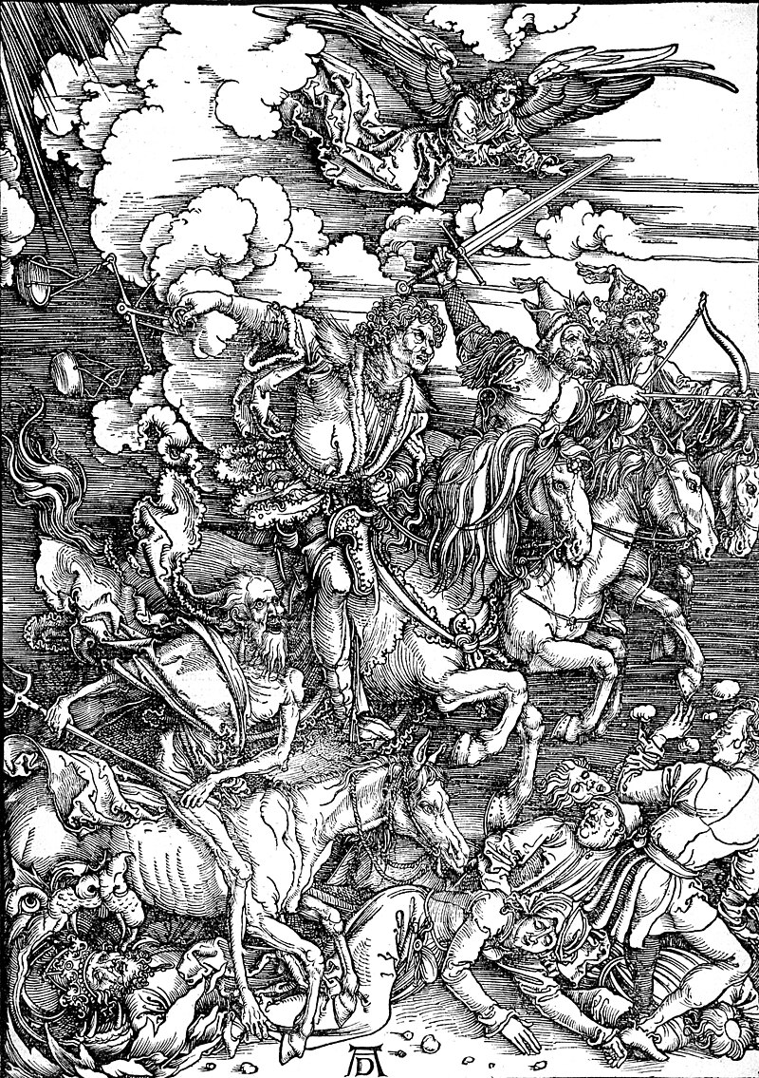

“The Four Horsemen of the Apocalypse” by Albrecht Durer, 1498

v. 9-11 – the fifth seal is the first in this sequence to not involve a horseman, or even God’s wrath against sin. Instead we see the saints beneath the altar:[50] the souls of the martyrs![51] These are the ones which were put to death on account of the word and their witness[52] of Jesus Christ. Wright notes that this is the only place in the New Testament where anything “definite” is said regarding “*the present state and location of the Christian dead*.”[53]

Caird writes that when a sacrificed animal was laid on the altar of burn offering at the Jerusalem Temple, the blood would run off and gather around the foot of the altar; “*John presumably has some such analogy in mind*” in the saints under the altar, as they have been “sacrificed” for holding to God’s word and the testimony of Jesus via their martyrdoms.[54]

These martyrs cry out to God, asking, “how long before you will judge and avenge our blood on those who dwell on the earth?”[55] This statement gives us a few important points to consider:

1. They’re not asking for permission to command angels to avenge their blood, and neither did their fellow Christians on earth avenge them; they are waiting for God himself to act.[56]
2. Perhaps shockingly to our ears, these souls (who are saved by faith alone through the atoning sacrifice of Christ on the cross for the forgiveness of their sins), are not crying out for God to convert their murderers or have mercy on them. They’re asking God, “how long until you judge and avenge?”[57] But this follows that which is taught in the Scriptures: that innocent/unavenged blood “cries from the ground,”[58] those guilty of murder were themselves to be put to death,[59] and finally, that God will avenge the blood of his people by destroying those who shed their blood.[60]
3. The death of these saints was terrible enough that, even in the presence of God and being saved in heaven, they not only remember being martyred, but their calling out for God to avenge their blood. That death is so horrifying, even for a saint, not only gives us pause, but helps explain why Christ himself prayed to the Father to “let this cup (of suffering and death) pass from me”[61] in Gethsemane.

Specific to the souls of the martyrs being underneath the incense altar: the altar of incense was the place where humans could physically see their prayers symbolically ascending to God, as the priests offered up incense to God.[62] So here, the souls of these Christians, who now God’s priests,[63] pray in God’s heavenly temple, as the saints on earth, who also are God’s priests,[64] still suffer on earth and pray for their deliverance.

These saints are given a white robe,[65] symbolizing the salvation Christ has given to them,[66] and through his blood shed for them,[67] that they are righteous before God in heaven. They are told to rest (be patient, at peace) for a “little time”[68] until the total number of their fellow Christians to be martyred is completed. The implication here is clear, that when that predetermined number of Christian martyrs is reached,[69] God will act with swift judgment, having entrusted all judgment to the Son.[70]

As Pre-Millennial Dispensationalists, LaHaye and Ryrie both fit all things into a seven year tribulation schematic. As such, they identifies these as the souls of the Christians who did not believe prior to the Rapture, but only afterwards, via the faithful witnesses which will be soon described in chapter 7 of Revelation.[71]

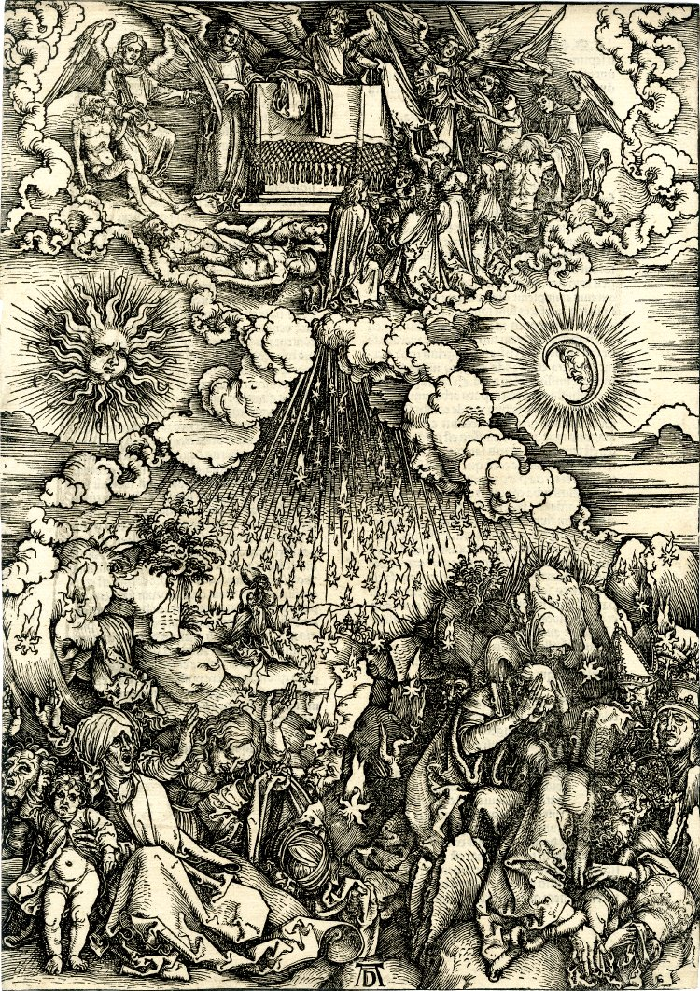

“The Opening of the Fifth and Sixth Seals” Albrecht Durer, 1498

v. 12-17 – right after telling the martyrs to be patient, Christ opens the sixth seal, and John sees the end of the world, and the terror it brings to those on the earth:

The end affects the heavens and the earth, as the whole created order is shaken.[72] The imagery is filled with references to what God had previously described when pointing ahead to the End: a great earthquake,[73] the sun turning black,[74] the full moon red like blood,[75] the stars falling from heaven to earth,[76] the sky disappearing as a scroll being rolled-up,[77] and every mountain and island removed/displaced.[78]

The wrath of God is so great, and terrifying, that sinful mankind (from kings to slaves and all between) hides in caves and among the rocks, calling on them “fall on us and cover us”[79] and their terror ends with the proverbial question on the great day of God’s wrath: “who can stand?”[80] As Poellot summarizes the End of the World as seen in these verses, v. 12-14 speak of things, v. 15-17 speak of people.[81]

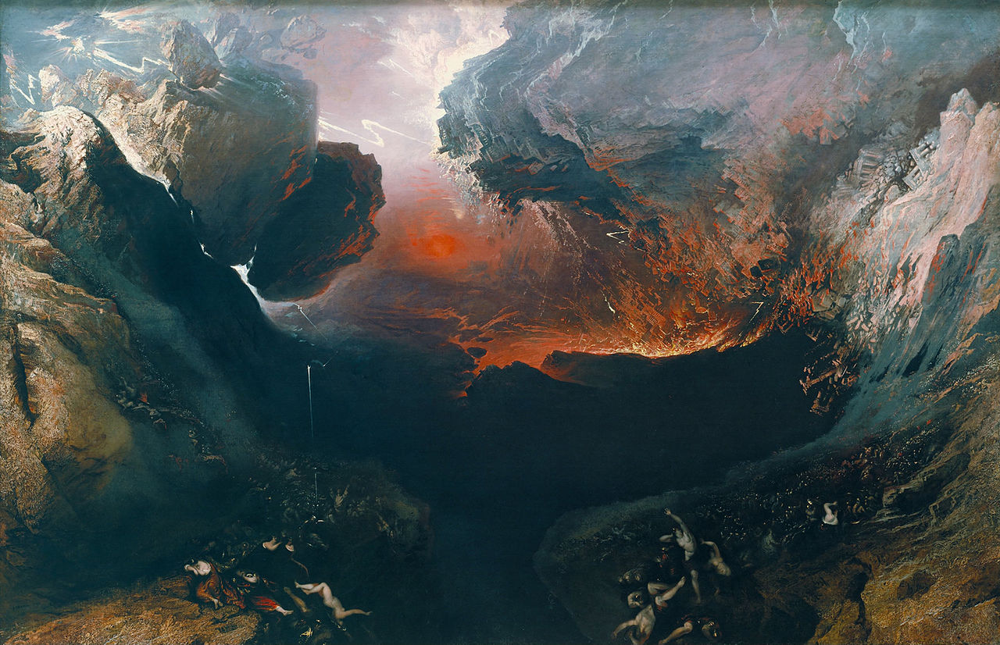

“The Great Day of His Wrath” by John Martin, 1789

In such terror, mankind seeks to hide themselves amongst caves and mountain rocks;[82] they even call out to the mountains and rocks, “fall on us and hide us” from the face of God the Father and the wrath of the Lamb, for the great day[83] of *their* wrath has come.

Hailey disagrees that this not the great and final judgment, but instead a judgment against “*whatever ungodly world power was persecuting the saints.*”[84] His lines of reasoning can be reduced to a) maintaining that the Old Testament imagery echoed by John here always pointed to localized judgment on individual nations only,[85] and b) that sinners have the time to try and hide, to Hailey, cannot happen at the Lord’s second coming, which is in the twinkling of an eye; he also argues that the quotation of Hosea 10.8, as it was initially uttered in the context of the destruction of Samaria by the Assyrians and Jesus used it to describe the coming destruction of Jerusalem by Rome, it cannot be pointing to anything other than a localized judgment.[86] Ryrie likewise denies the obvious world-ending imagery seen by John, even reducing “the sky vanishing like a scroll being rolled up” to merely heaven being momentarily opened to give humans a glimpse of God on his throne,[87] and “the great day of his wrath” merely a recognition that the Tribulation has begun.

Thus ends the first threefold vision; it must be noted here the similarity between what John sees in the breaking of the seven seals, and what Christ himself described in the Olivet Discourse, specifically Matthew 24,[88] a section which many scholars have dubbed “the Little Apocalypse”:

Matthew 24 Revelation 6

False Christs (v. 5) the white horse/antichrist (vs. 1-2)

Wars & rumors of war (v. 7) the red horse/war (vs. 3-4)

Famines (v. 7) the black horse/famine (vs. 5-6)

Pestilences (v.7: Luke 21.11) the pale horse/death (vs. 7-8)

Earthquakes (v. 7) earthquake (v. 12)

Persecutions (v. 9) souls of martyrs (vs. 9-11)

Then the End shall come (v. 14) the End (vs. 12-17)

**Revelation 7**

Verses 1-17 – Interlude: The Church Militant and the Church Triumphant[89]

v. 1 – Four angels, four corners, four winds: rather than referring to a flat, four-cornered earth, the “four corners” are a reference to the totality of the earth via the four primary points of a compass rose: north, south, east, west.

In ancient Jewish thought (as demonstrated in the apocrypha and pseudepigrapha), angels operated under God’s divine providence to control the natural elements/ forces of nature;[90] but in the New Testament, only in Revelation are angels described in this way. The “four winds” they are holding back, Brighton argues, are the four horsemen of chapter 6, given that A) holding them back is preventing them from harming others, and B) Zechariah 6:1-8 identifies those four chariots & horses witnessed as riding on the four winds of heaven. Elsewhere in the Old Testament, the “four winds” are described as agents of God to bring judgment and calamity upon sinners.[91]

v. 2-3 – a fifth angel[92] comes “from the east”[93] with a specific task to accomplish: he calls upon the four angels to hold back the four winds,[94] until the full number of God’s saints can be sealed. Interpretations vary as to what these “winds” are – actual winds, or the winds of warfare,[95] persecution, or adversity against the church of any kind.

Some ancient Christian writers described the “seal of the Lord” as being baptism,[96] but this view was not universal.[97] The New Testament describes God sealing his people through his Word, marking them as his and guaranteed to receive his salvation.[98] Those sealed here are later seen in Revelation 14.1-3, mentioned as those “with [the Lamb’s] name and his Father’s name written on their foreheads,” and the redeemed in the world to come are described as “his name will be on their foreheads” (22.4).

That God’s people would be sealed to set them apart from God’s wrath to come[99] is itself an echo of an Old Testament event, when Ezekiel (who, with others from Judah was already exiled in Babylon) saw God send out a man to mark[100] the faithful (to be spared), and was followed by those who were instructed to slaughter all in Jerusalem who were unmarked.[101] Brighton notes that, as the sign was visible in some way, the modern day “signs” of the redeemed being sealed by the Spirit of God for salvation are that of the Sacraments: baptism[102] and the Lord’s Supper, both of which can be witnessed with the human eye. Hailey notes that, as they are sealed on the forehead, everyone who beholds them will recognize that they belong to God, and while they would not be spared from persecution, they would be preserved against destruction.[103]

Wright directly connects those sealed (the 144,000 of which he heard) from verses 4-8 with those redeemed (the innumerable multitude of which he saw) from verses 9-17, as they are the redeemed, the same body of believers, be they on earth (the Church Militant) or in heaven (the Church Triumphant). As such, he properly points out that this sealing is *not* a sealing to ensure that they are spared from suffering, but that they will pass through death to life.[104]

v. 4-8 – the 144,000 sealed (the Church Militant).[105]

As these 144,000 are referred to as “from every tribe of the sons of Israel,” some commentators from ancient times to modern have maintained that this is specifically regarding only Jewish believers in Christ,[106] but the majority of commentators recognize this as the total number of Christians on earth, Jew and Gentile alike, in the time period from his Ascension to his Second Coming.

The New Testament makes clear that the Church is the New Testament Israel,[107] the chosen nation and royal priesthood of God, identified as believers in Christ, both Jew and Gentile. As such, in the Revelation it should not surprise us to see the true Church described figuratively in “Old Testament language,” such as the redeemed of every tribe and nation (both Jew and Gentile alike) being identified as the twelve tribes, based on Jacob’s physical sons.[108]

144,000 is not to be taken literally; not only are they later identified in 14.1-5 as being only consecrated male virgins[109] of a limited number, the host of the redeemed in heaven is described later this in this same chapter as “so many that no man could number them” in 7.9, and would certainly include any and all faithful women. As 144,000 is merely 12 x 12,000, this is a symbolic number describing “total completeness.”[110] This depiction shows God’s complete church on earth, militant and in formation,[111] ready to follow the Lamb through a world ending.[112] That said, Caird does not make a distinction between the 144,000 on earth and the great throng seen in heaven later this chapter.[113]

The twelve tribes, as listed from verses 5-8 do not match any Old Testament listing of the twelve tribes; they are not listed by birth order, birth mother, allotment of land, or encampment/marching orders. In this listing, Dan is missing entirely, and the two half-tribes of Joseph (Ephraim and Manasseh) are instead listed as Manasseh and Joseph. Thus, two of the land-allotted tribes (Dan and Ephraim) are missing, while two tribes that received no territory in the Promised Land (Joseph and Levi[114]) are included.

Dan and Ephraim’s omissions are left unexplained by John, but Old Testament history can help explain: the tribe of Dan only briefly took possession of the land allotted to them by God thru Joshua; driven out of their land, they took the hill country of Leshem by force,[115] setting up the carved idol of Micah and paying a counterfeit priest named Jonathan to serve them (Judges 18), and later hosted one of the two golden calves built by King Jeroboam I as an alternative worship site to the Temple in Jerusalem.[116] By the intertestamental period Dan was associated with idolatry, and Irenaeus in his *Against Heresies* wrote that, as the Christ came from Judah, the Antichrist would come from Dan.[117] Ephraim too was associated with this idolatry early on: Micah, who created his own carved idol and hired his own counterfeit priest Jonathan (both of whom ended up in Dan) was from the tribe of Ephraim,[118] and Jeroboam, who rebelled against Solomon, became the first King of Israel (contra Rehoboam, King of Judah), built the calf idols of Bethel and Dan, and founded the rebellious northern kingdom of Israel, was also descended from Ephraim.[119]

v. 9-17 – the redeemed in heaven (the Church Triumphant)

v. 9 - In contrast to the small, specific number of the Christ-followers on earth,[120] the revelation transitions to a vision of the redeemed in heaven itself, where he sees a great multitude that no man could number,[121] from every nation, tribe, people group, and languages, in the presence of the Lamb and his throne: these are all the redeemed, on back to Adam and Eve and forward to John’s time (with the possibly that John was given a vision of the redeemed yet to come, forward to our time and to the final redeemed to die before the Second Coming).

Whereas the 144,000 are describe in equal ranks and as those ready to militantly follow Christ on earth, the redeemed in heaven, the Church Triumphant, [122] is presented “at rest,” sheltered in God’s presence, spared from hunger, thirst, sun or heat, with all tears wiped away from their eyes.[123]

This is the third time John sees the redeemed in heaven wearing white robes;[124] these white robes symbolize purity and righteousness of Christ himself, whose blood shed for these obtained their forgiveness, making them righteous by faith alone.[125]

The palm branches[126] harken through the history of God’s interactions with his people in terms of both acts of mercy and of history: engraved palm trees adorned the Temple of Solomon[127] and the restored temple in Ezekiel’s vision,[128] palm branches were to be used (along with other trees) while celebrating the Feast of Tabernacles/Booths,[129] palm branches were carried to celebrate the purification of the Temple during the Maccabean period,[130] and most especially, were used to celebrate the triumphal entry of Christ Jesus into Jerusalem on *Palm* Sunday.[131]

v. 10-12 – Here is another part of the hymn[132] of praise which winds its way throughout the Revelation – it began in 4.8 & 11,[133] was picked up again in 5.9-13[134] and continues here, with the redeemed singing to God on the throne (and to the Lamb), and the angels worshipping “our God.”

v. 13-14 – this multitude, and from where they came,[135] are identified by one of the twenty-four elders:[136] they are the ones coming out of “the Great Tribulation.”[137] This interlude of the sealing of the church militant and the rejoicing of the church triumphant comes after John had just finished seeing the Great Tribulation, and the horrific terror of the end, with the breaking of the six seals.[138] John stated to his fellow Christians at the very beginning of his work that he was their partner “in the tribulation, the kingdom, and the patient endurance that are yours in Christ Jesus” (1.9), but this one is specified by the elder as “the Great Tribulation.”

Is this “Great Tribulation” to be identified as the general tribulation which the church experiences throughout the whole time between Christ’s ascension and Second Coming,[139] or is this a chronologically limited tribulation which is far more extreme than what the church had already suffered? Brighton first argues that there will be a great tribulation to occur near the end of the church age, immediately before the Second Coming, based on Christ’s Olivet Discourse[140] and that his description of “a great tribulation such as has not been from the beginning of the world until now, no, and never again will be,”[141] described as so terrible that, had those days not been cut short, not even the elect would be saved.[142]

Brighton then points out that the participle in 7.14 is present tense, thus these are the ones who *are coming* out of the Great Tribulation, which John saw in the first century AD. From there, Brighton argues that this condition of blessedness is a promise to all Christians, including those who die long before the final, Great Tribulation occurs. Thus, it is proper to describe the suffering in which all God’s people existing in all times pass as the “Great Tribulation” as Poellot does, but also to recognize that, immediately preceding the end, there will be a “Great Tribulation” in which things become tremendously worse, as Brighton does.

On the other hand, Greene posits that the group John sees here is limited to those saints still on earth, after the rapture, who believe in Christ thanks to the preaching of the 144,000 Jews,[143] a position which has no support within historic Christianity before the latter part of the nineteenth century. Hailey, while noting that the previously mentioned position “*has no foundation in Scripture*” identifies this Great Tribulation as that which John himself was living through: the Roman persecution of the church which began with Nero and continued until the Edict of Constantine. Hailey thus confines John’s vision here to a specific 249-year period which has long since passed into history.[144]

The redeemed are described as “they have washed their robes and made them white in the blood of the Lamb,” which emphasizes their salvation as having been accomplished through the forgiveness of sins obtained by Christ, who purchased them with his holy, precious blood and innocent suffering and death.[145] Interestingly, the elder says *they have washed*. This describes Christians who, after having been made alive by God through the gift of faith,[146] then hold to Christ in repentance and faith, and in so doing, bear the fruits of faith which they are expected to bear.[147] Salvation is from God alone, as he alone instills the desire, prompts the action, and accomplishes the result when it comes to our repentance and faithfulness; our cooperation, while present, is at best feeble compared to God’s righteousness;[148] that said, God’s saints are not called to be entirely passive: our good works are expected by God,[149] with Christ frequently describing judgment on his servants based on their actions,[150] and in Revelation (19.8) and elsewhere, the righteous actions of God’s people are described in a positive correlation to their reception of proportionally-based eternal blessings.[151]

v. 15-17 – these verses emphasize the eternal communion with the redeemed and God: in his presence, worshipping and serving him, God dwelling with his people (shelter with his presence),[152] no hunger or thirst,[153] no striking from the sun’s heat[154] nor any other scorching heat,[155] the Lamb as their shepherd[156] who guides them to living water,[157] and God wiping away every tear from their eyes.[158]

a. this wiping away of all tears involves the removal of all those reasons for which we cry in a sinful world: our sins and the sins of others, pain, loss, afflictions of ourselves and our loved ones, yet Christ promises that our tears will turn to joy.[159]

b. it is also likely that these tears being wiped away will be the tears shed by the redeemed over loved ones who had rejected God’s offer of salvation in Christ and instead are eternally lost and condemned.

**Revelation 8**

Verses 1-5 – The Seventh Seal Introduces the Second Sevenfold Vision

v. 1 – whereas the first six seals resulted in terrible judgments on earth and the martyrs in heaven calling out for vengeance, the seventh seal results in “silence in heaven for about half an hour.” This silence is not explained or expounded upon, so what are we to make of it?[160]

Oecumenius tied this silence to Christ’s second coming (occurring immediately following the end of the physical world in the sixth seal), as all the angel powers of heaven being held in silent awe at the superlative glory of Christ as he comes. Victorinus expanded upon Jerome’s commentary on Revelation to suggest that this silence corresponds to the eternal rest of the heavenly Sabbath,[161] similar to God’s rest following the completion of creation.[162]

Brighton notes that Jewish intertestamental literature contains numerous references to silence being present before creation,[163] and the belief that there will likewise be a widespread, “*primeval silence*” which would precede the resurrection of the dead and the final judgment.[164] Likewise in the Apocrypha, the Wisdom of Solomon[165] says that a silence and peaceful rest preceded the angel of death’s descent to strike down the firstborn Pharaoh and Egypt.[166] Metzger describes this as *“the solemn hush before the bursting of a hurricane. The effect of the pause is to heighten the horror of the next series of God’s judgments.”*[167]

Greene, in an attempt to force Revelation to fit into a chronological framework, argues that the seventh seal includes all seven trumpets, and the seventh trumpets includes all seven vials, and thus concludes that *“you do not wonder that all heaven stood speechless when this terrible judgment was revealed.”*[168] Fellow Rapturist LaHaye similarly writes, *“These judgments* [the trumpets to come] *are so terrible that the angels stand breathless in wonder.”[169]*

v. 2 – John then sees “the seven angels who stand before God,” and they are given seven trumpets.[170] That they are identified by a definite article[171] identifies them not as seven random angels, but as a specific, definitive group of seven.[172] Jewish tradition at least a couple centuries prior to John recognizes the existence of seven archangels.[173] The apocryphal Tobit sees Raphael identify himself as one of the “seven holy angels,”[174] but as far as named, holy angels go, the Scriptures identify only Michael[175] and Gabriel.[176] Nowhere in the Scripture aside from Revelation are seven archangels (or any group of seven angels at all) mentioned.[177] Most commentators are comfortable identifying these seven angels who blow the trumpets as the seven archangels identified in 1 Enoch, but not all.[178]

v.3-5 – Before these seven blow their trumpets, another angel[179] with a golden censer[180] steps into the Revelation: this angel offers incense and the prayers of all the saints[181] up to God[182] from his altar,[183] then fills the censer with fire, and upon throwing it to the earth, brought about lightning, thunder, rumblings, and an earthquake.

Censers have been used in the worship of God since the Exodus,[184] with an incense altar included in the specifications for the Tabernacle[185] and in the Holy of Holies within Temple, and the prayers of the saints are likened to the incense rising to God.[186]

Throwing fire from God’s altar upon the earth is an act of judgment, like Ezekiel saw a man clothed in linen take burning coals from among the cherubim and scatter them amongst Jerusalem as an act of judgment against them.[187] Fire frequently in the Old Testament is the imagery to describe the fierce and consuming anger of God against sin,[188] and the sinful condition of earth guarantees that the response from heaven will be anger and wrath against that sin.[189]

Verses 6-13 – The First Four Trumpets: Upheavals in Nature

v. 6 – whereas from Revelation 2.1 - 8.5 the mediator to John was Christ himself,[190] upon Jesus opening the seventh seal, the mediator(s) between God the Father and John, speaking to John directly, is no longer Christ himself,[191] but angels. The Old Testament is full of God’s personal appearance to man as a heavenly figure in human form, or more specifically, as the Angel of the LORD,[192] and Stephen, Paul, and the writer of Hebrews specify that the Law/Torah was given on Mt. Sinai through angels.[193]

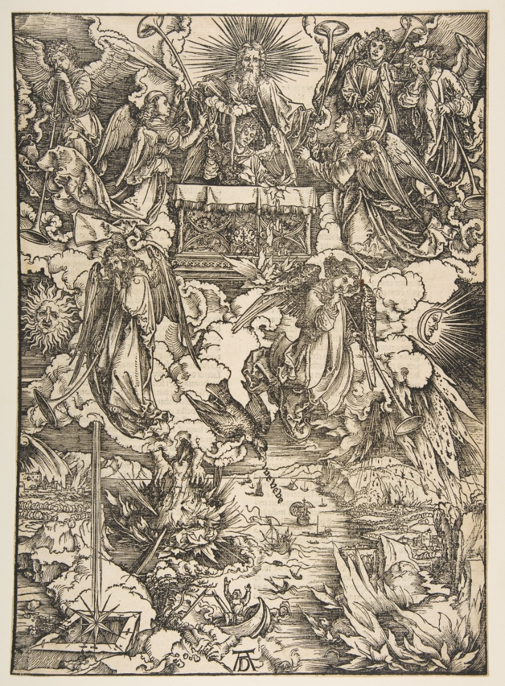

“The Seven Angels with Trumpets” by Albrecht Drurer, 1511

God mediates through angels is due to human beings, in their sinful condition, being unable to appear before God in his unmediated divine glory.[194] Brighton argues that it is the inability of humans to stand before Christ as exalted and glorified Lord, that Jesus uses angels to mediate *the majority* of the Revelation to John.[195] Revelation does not indicate why the mediation came from Christ at first, and thereafter from angels.[196]

A trumpet blast is part of the signaling of the Day of the LORD,[197] signaling God’s arrival for deliverance and wrath,[198] and a great trumpet signals deliverance for the faithful, who will gather and worship,[199] but none of these verses specify that it will be an angel who blows the trumpet. It was in the pseudepigrapha that angels blowing trumpets are explicitly described as indicative of God coming with judgments at end of the world: 4 Ezra 6.18-23 indicate the coming of the Lord in judgment, accompanied by plagues and terror, and the Apocalypse of Abraham 31.1-3 speaks of God’s chosen one arriving to gather his people and punish the wicked.

By the time Christ came, the connection of angel trumpeters and the End of the World was so prevalent in the minds of the faithful that Christ himself says he will, with a loud trumpet call, send out his angels to gather his redeemed at his [second] coming;[200] this theme is echoed by Paul to specifically coincide with the return of Christ and the resurrection of the body on the last day.[201] That said, Hailey, ever contrary, holds that these seven trumpets serve as partial judgments on the wicked, mere warnings of greater judgments to come.[202]

v. 7-12 – whereas the six seals obviously imply a large amount of death upon the world’s population, it is here in Revelation that massive numbers of deaths are specified:[203] repeatedly, a third of mankind killed by these judgments of God;[204] that there is an emphasis of on the lack of penitence among the survivors (9.20-21) tells us that a major part of these punishments is to drive sinners to repentance before it is too late; God’s ultimate purpose is repentance and salvation.[205]

v. 7 – the first trumpet blown results in “hail and fire, mixed in blood” thrown upon the earth, with the result that a third[206] of the earth, a third of the trees, and all the green grass is burned up. This is similar to, but more extreme, than the seventh plague upon Egypt: that of hail mixed with fire, thunder and lightning,[207] and is similar to a threat God made through Ezekiel towards the eschatological enemy of his people, Gog.[208] In Egypt, the hail and fire destroyed the “plants of the field” (crops) and trees, as well as killing livestock and slaves left out in the open;[209] only Goshen, where the Hebrews dwelt, was spared. This act of judgment described here is far more catastrophic, destroying a third of the earth, a third of the trees, and all the green grass.

A third, however, represents not total, but only partial destruction. But given human dependence on crops and grasses[210] for food, even such partial destruction easily leads to conditions of famine and starvation.[211] Brighton notes here that, at any given point in earth’s history, some parts of the earth’s vegetation will be affected.[212] Poellot suggests that these might be tied to how unbelievers have treated God’s people in the past – those who stoned the saints are stoned by God via hailstones, those who burned the saints are burned by God via fire, those who shed the saints’ blood are punished in receiving their own violent deaths.[213]

v. 8-9 – the second trumpet is blown by the second angel, and John sees “something like” a great mountain, burning with fire, thrown into the sea, turning a third of the sea’s waters to blood, killing a third of all animals in the sea, and destroying a third of the ships. This is similar to, but more extreme, than the first plague upon Egypt, where all the waters of the Nile[214] turned to blood, killing its fish.[215]

In the Old Testament, Mt. Sinai was described as a mountain burning with fire when God appeared upon it to Moses.[216] Also, in speaking of judgment against Babylon, God describes Babylon as a “destroying mountain” and promises to destroy it, turning it into “a mountain of burning.”[217] In 1 Enoch, seven stars/evil angels are seen as falling from heaven to hell as burning mountains.[218]

Numerous commentators have noted that, in the Aegean and eastern Mediterranean, there are numerous “mountains of burning” right next to the sea, such as Mt. Vesuvius, which erupted in 79 AD and destroyed Pompeii and Herculaneum. Brighton notes that this fiery mountain “probably” symbolizes natural events (namely volcanic eruptions) throughout history which strike earth’s seas, killing wildlife and affection maritime activity of humans.[219] LaHaye, unusually, limits his interpretation of this calamity: a meteorite that falls into the Mediterranean, and its effects are limited to the Mediterranean basin only.[220]

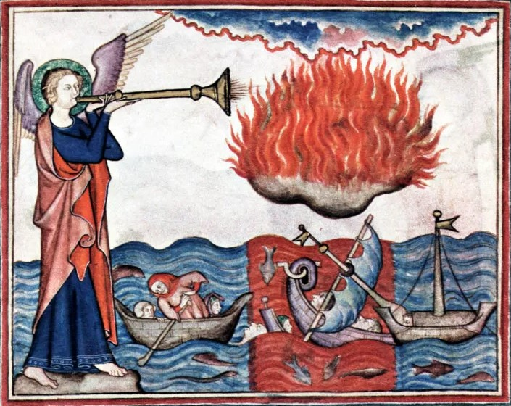

Huge Mountain, Ablaze – 14th century Norman Apocalypse

v. 10-11 – the third trumpet blown by the third angel results in a great star named Wormwood[221] falling from heaven upon a third of the rivers and springs of water. The affected waters became wormwood, and many people died from this bitter water. Unlike the first two trumpets, this judgment has no correlation to the ten plagues upon Egypt,[222] but instead points to Jeremiah’s message against his sinful people in Jerusalem: God will give his people bitter food to eat and poisonous water[223] to drink because of their sins against him.[224]

Important to note is that this star fell “from heaven” as a response to the third angel blowing the third trumpet, is that this is an act of divine judgment upon sinful humanity. Throughout history, a portion of earth’s waters will be so polluted as to harm and kill those that consume it.[225] LaHaye assumes that this is another meteorite, which lands precisely where “*the headwaters of three great rivers come together*” and many are killed as these three great rivers are poisoned.[226]

Poellot notes that some interpreters view this to indicate that an outstanding person (star) was rejected by God (fallen from heaven), and the false doctrines they taught led to the destruction of souls (the bitter waters which killed). He notes[227] that Luther had this interpretation, with Luther suggesting possible fulfilments in Origen,[228] Pelagius,[229] Arius,[230] or Pope Gregory the Great.[231]

v. 12 – the fourth trumpet sounded by the fourth angel results in partial darkness throughout creation: a third of the sun, and of the moon, and a third of the stars were struck so that a third of their light was darkened, thus affecting a third of the day and a third of the night as well. Whereas the ninth plague upon Egypt was a darkness so thick and deep that “it could be felt,” this darkness upon Egypt did not affect the Hebrews in Goshen, and it lasted three days.[232] Whereas on the surface this turmoil never results in pitch black, the total amount of darkness – a third of creation for the duration of history – is cumulatively more.

Brighton admits that it is difficult “to relate this partial darkness to human experience” and wonders if, since eclipses of the sun and moon don’t seem to correlate to the inability of the heavenly bodies to produce their light for earth’s benefit, if this means that the clouds, smog and pollution in the atmosphere makes it increasingly difficult for light to shine.[233] Conversely, light pollution ensures that only a small percentage of stars shining at night can actually be seen in crowded areas.[234] LaHaye’s interpretation, and math, concludes that this will result in earth experiencing days of eight hours of daylight and sixteen hours of darkness.[235] As Poellot interpreted the third trumpet as the proliferation of false teaching, so too here he identifies the darkness as false doctrine and religious delusion, given that the Word of the Lord is proclaimed as a lamp and a light.[236]

The darkening of the heavenly bodies in the Old Testament are signs of God’s judgment against the sin of mankind, and such darkness is frequently connected with God’s wrath, described as “the Day of the LORD.”[237] In describing the end of the world during the Olivet Discourse, Christ too emphasizes the sun being darkened, the moon not giving its light, and the stars falling from heaven.[238]

The cumulative effect of these first four trumpets (occurring over the same period of history as the four horsemen ride) presents a frightening, yet coherent picture of creation itself in turmoil, of plants, fresh and salt water, and the heavenly bodies themselves being affected by God’s wrath.

v. 13 – as a transition between the four divine, natural disasters to the three demonic woes to come, an eagle[239] is shown flying between heaven and earth, pronouncing[240] “Woe, woe, woe”[241] to the inhabitants of the earth, for the next three trumpets to sound. “Woe” is a common Biblical term to describe those whose judgment is so sure, “they’re as good as dead already.”[242] That this proclamation of woe comes for the next three plagues but not the first four, naturally implies that the final three will be significantly worse than the ones preceding.

**Revelation 9**

Verses 1-21 – The Fifth and Sixth Trumpets: Demons from the Abyss & the Last Battle

v. 1 – the fifth angel blowing the fifth trumpet shows the beginning of a rather long sequence, beginning with “a star, fallen from heaven to earth, and he was given the key to the shaft of the bottomless pit.” There are several noteworthy things in this one verse:

a. the “star” is later called “he.” Angels are identified as stars elsewhere in Revelation[243] and the Bible. This specific star is later identified as “the Angel of the Abyss,” named Abaddon and Apollyon (v. 11). Brighton states that the identity of this angel is unmistakable, and is later identified in Revelation 12.9 as the devil and Satan.[244] He will occupy a large portion of the Revelation from chapters 9 – 20.[245]

b. the perfect participle for “fallen” is used here, meaning not “had fallen” or “will fall,” but more along the lines of, “is fallen and will always remain fallen.” Isaiah 14.12-15[246] compares the fall of a star from heaven to the coming fall of the King of Babylon, and Jesus specifies, “I saw Satan fall like lightning from heaven.”[247]

c. “He was given,” in that even this demonic calamity to come is under the control and auspices of God, similar to Job’s sufferings at the hand of Satan were allowed by God[248] – Satan could go “so far, but no further.”

d. the term here for “bottomless pit” is literally *The Abyss*.[249] In Revelation, John uses this term to describe the abode of Satan, demons and the unrighteous,[250] rather than the other terms used in the New Testament and translated as hell: Hades,[251] Gehenna,[252] or Tartarus.[253] Hailey summarizes that the Abyss is the present abode of the devil and his demons, but upon judgment, will be punished forever in in the eternal fire[254] / lake of fire and brimstone.[255]

v. 2-10 – considerable time is spent describing this horde which emerges from the Abyss![256] They are called “locusts,” yet are anything but swarming grasshoppers:[257] described as horses prepared for battle, having what appears to be[258] crowns of gold, human faces, women’s hair, lion’s teeth,[259] and breastplates of iron with scorpion tails,[260] with which they cause tremendous harm for a period of time,[261] this hellish horde is a horde of demons[262] – yet they have the authority to harm[263] only those without the seal of God upon their foreheads.[264] Like previous trumpets, this judgment too amplifies that which was unleashed upon Egypt – specifically the eighth plague, of locusts.[265] Wright notes that many recent commentators have tried to identify these locusts as modern military machines, such as attack helicopters – a move that “domesticates” them!

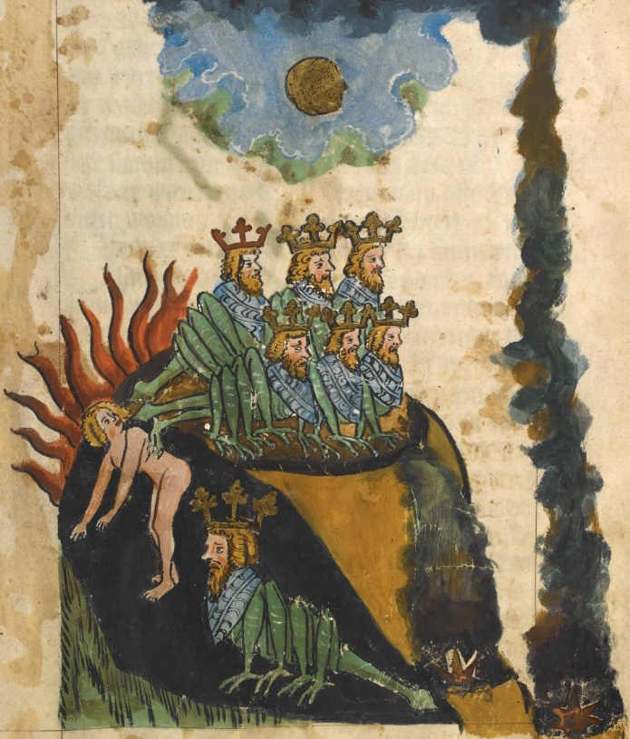

Locusts from the Abyss – 14th century German Apocalypse

That specific instruction of verse 4 points out a sobering fact about this demonic horde: them being set loose upon the earth is part of God’s wrath upon the sinful world[266] – yet, like the army unleashed by the sixth trumpet, the goal of God’s wrath is that those who are being punished repent,[267] and their lack of repentance is noted by John.[268]

The “five months” is a time period which is, in Revelation, entirely unique, and in the whole Scripture is only mentioned one other time.[269] Even the number, five, is itself only used in one other place within the Revelation.[270] Hailey gives a number of suggested ideas, but after dismissing them, suggests that “five months” merely gives “definiteness” to God’s judgements, such as the five wise vs. five foolish virgins or the parable of the five talents.[271]

v. 6 – Hailey comments, rather oddly, that for those who seek death but cannot find it, and long to die but it flees from them, this represents those whose lives have been so polluted by sin that physical death is of no gain to them, and their anguish of soul cannot be assuaged by death. He argues, *“This is why they do not commit suicide.”*[272] Metzger describes the suffering caused as being so great that death is seen as preferable to the agony of living, but notes that physical death is no remedy for the torment of an evil conscience.[273] Poellot writes that this torment drives its victims to despair and cannot even be relieved by death,[274] while Ryrie graphically describes this in a literal manner: *“Bodies will sink and not drown; poisons and pills will have no effect; and somehow even bullets and knives will not do their intended job.”[275]*

v. 7 – these locusts are wearing *what looked like* crowns of gold. Elsewhere in Revelation, a crown or crowns[276] of gold are always described as being worn by Christ’s servants,[277] with only two exceptions: here, and the first of the four horseman, the rider on the white horse (6.2).

v. 11 – “The angel of the abyss” here is named: in Hebrew, Abaddon[278] & in Greek, Apollyon.[279] Both of these terms/names in both of these languages have the same meaning/name: *Destroyer*. Brighton notes here a possibly connection between “Apollyon” and “Apollos,” as the Greek deity Apollos had as a symbol, among other creatures, the locust, and his temples were found throughout the Empire.

Hailey’s explanation of this woe is to say that the clouds of smoke from the Abyss contaminated the moral and spiritual atmosphere of earth, corrupting and debasing the minds of men, and the resulting torment which accompanied the decay and corruption of mankind.[280]

v. 13 – 14 – the second woe comes as the sixth angel blows the sixth trumpet: a voice[281] from the altar[282] tells the angel who had just blown the aforementioned sixth trumpet[283] to “Release the four angels bound at the great river Euphrates.”[284]

Brighton maintains that the seven angels of the seven churches, the seven trumpet angels, and the seven bowl/censure angels are the same seven, in the same order. As such, he notes that the sixth angel here is also “the Angel of the Church of Philadelphia,” and relates Christ’s message to the church in Philadelphia to “keep them in/from the hour of trial” and the terrible actions about to be unleashed by the sixth trumpet angel.[285]

From the perspective of the Holy Land, the Euphrates lies to the northeast and east, and in God’s promise to Abram, was, with the Nile to the west, the far extremity of the Promised Land itself to the northeast;[286] this verse, along with the first horseman resembling a Parthian (6.2) and the Euphrates drying up to allow an invading army (16.14) reiterates the fear of invasion from the east.

v. 15 – 19 – Speaking directly to God’s divine foreknowledge, these angels had been prepared for the exact moment of their release, down to the day, month, and year. Their mission: to kill a third of mankind. They are described as leading cavalry numbering twice 10,000 x 10,000, with the horses bearing the heads of lions, and able to kill via fire, smoke, and sulfur coming out of their mouths, and bearing tails which were serpents.[287]

Who are these four angels? Andreas[288] believed that they were the most evil of the fallen angels/demons, but notes that other writers believed them to be angels of God, specifically Michael, Gabriel, Uriel, and Raphael. Brighton notes that the word “angel” in Revelation always refers to the holy angel(s) of God, and never the forces of evil, unless specifically identified as such.[289] He identifies them as the same four angels of 7.1-3, who hold back the four winds (which are the four horsemen) until God’s will permits them to be unleashed. They are, simply put, angels of judgment and punishment, both inflicted by other sinful people, or by demons, but ultimately under God’s control;[290] Greene is emphatic that these four are not the four from 7.1-3, as the four in chapter seven are at the “four corners” of the earth, and these four are bound at the Euphrates.[291] God using angels to inflict punishment is quite Biblical,[292] and as all human beings are sinful creatures, God using angels to kill a third of all mankind is perfectly reasonable; God using *holy angels* to lead a *demonic horde* in punishment of sinful humanity though, is admittedly a difficult concept with which to wrestle.

That they are held for a specific moment of release indicates that, unlike the four horsemen or the events of the first five trumpets, the slaughter at the hands of these angels is not occurring throughout the whole period from Christ’s ascension to return, but rather for a definite period.[293] That this occurs at the final trumpet before the seventh angel blows his trumpet and the world ends, suggests that this definite period of slaughter marks the time immediately preceding the End.

Whereas John saw the demons afflict people but not kill them due to the fifth trumpet, here, he hears their numbers of cavalry as death hunts down and extinguishes human life on a massive scale. Brighton argues that these four (holy) angels lead the forces of evil against mankind,[294] and that as the three plagues are of fire, smoke, and brimstone,[295] John most likely would have remembered the eruption of Mount Vesuvius.

It is always helpful to remember that the focus of these visions is to reassure the Church that it will survive in the midst of persecution; the first four of the seven seals show humanely-made disasters, and the first four trumpets, natural disasters, but the fifth and sixth trumpets point to what can be seen from one perspective as the foul, destructive forces of hell unleashed on earth, on from another, the brutality massive armies slaughtering other humans in their path (combatant and non-combatant alike). Wright describes the 200 million as, from the perspective of John writing to the church, *“Think of your worst nightmares; now double them; and then imagine them coming true all at once, together. That’s what it’s going to be like. This is God’s way of letting evil do its worst, so that it may eventually fall under its own weight.”[296]*

v. 20 – 21 – the section ends on a tragic note: the rest of mankind (those who survived the onslaught of the four angels and their 200-million strong cavalry of horse-demons) did not repent of their sins of idolatry,[297] murder, sorcery,[298] sexual immorality, or thefts.[299] Hailey emphasizes that, as this demonic army killed those unsealed by the Lamb and those they didn’t kill refused to repent, this judgment was only against the wicked, worldly, and rebellious against God.[300] Hailey also connects this woe to warfare in general, as the armies on earth, inspired by Satan but used by God, as executing God’s wrath upon idolatrous mankind.[301] Metzger too notes that this dire imagery here (and with all the trumpets) is given to produce repentance, as God’s great patience and mercy is evident in that, rather than the total destruction of unrepentant mankind, only a third are affected.[302]

While not explicitly stated here, Brighton[303] links the sixth trumpet with the sixth bowl/censer of God’s wrath (both with a connection to the river Euphrates, see Revelation 16.12) and views this as one view of the last great affliction on earth, “the Last Battle,” also called “the Battle of Armageddon.”[304]

**Revelation 10**

Verses 1-11 – Interlude, Scene One: The Mighty Angel from Heaven Commissions John

v. 1-2 – here begins an interlude,[305] in two scenes, between the sixth and seventh trumpets. Another mighty[306] angel from heaven comes down, standing on both the sea and the land, with a little book[307] in his hand.[308] This angel’s[309] duty is, essentially, a recommissioning of John to continue writing down what he sees and hears.[310] Whereas the book given to Christ alone in chapter five was sealed, larger, carried the eternal destiny of all that God would accomplish, and only Christ himself was worthy to receive it, this little book is already open: it focuses on a single aspect of God’s plans and purpose, and could be understood by John.

That the angel stands on both sea and land demonstrates that he, and the mission on which God sends him, will dominate the whole earth, including all peoples and endure throughout all history. For this angel to stand over the whole orb of the earth is to suggest a size/stature which is not exceeded by anyone in all creation[311] – except for God himself.[312]

v. 3-4 – the angel calls out with the mighty voice of a lion,[313] and a reply is given by “the seven thunders” – and John is ready to write down[314] what they said, but is immediately prohibited[315] from writing down what it was the seven thunders said![316] Nowhere else in the Bible are “the seven thunders” even mentioned, yet the presence of the definite article “the” before them indicates that they are a specific entity. God’s voice is likened to thunder,[317] and Rabbinic tradition asserts that atop Mount Sinai, God spoke to Moses in a thunderous voice, which divided itself into seven voices, which in turn divided itself into seventy languages.[318]

v. 5-7 – the mighty angel raises a hand and offers an oath to heaven,[319] that when the seventh trumpet is sounded, there would be no more delay,[320] and the mystery of God would be fulfilled. The mystery is stated as being “the one announced to his servants, the prophets,” without further qualifications – most likely being the promise of the Messiah’s work being completed by the eternal vindication of the righteous and the eternal punishment of the wicked.[321]

v. 8-11 – John is told by the voice from heaven (God the Father) to take the scroll from the angel’s hand; in doing so, the angel instructs John to eat it, with the detail that it will be sweet as honey in his mouth, but turn his stomach bitter (both of these things are true). John is then instructed to “again prophesy about many peoples, nations, languages, and kings.” In this, John is like Ezekiel, to whom God appeared and instructed to eat a scroll,[322] which will taste as sweet as honey,[323] and then to prophesy to God’s people both in exile and those still left behind in Jerusalem.[324] Wright notes that this is an example of the performative action of God, of his words creating reality, and that while new things are yet to happen, John’s words will bring them to pass.[325]

The bitterness is explained by what follows in the following chapter, which itself is but a reflection of the saving ministry of Christ itself, of which the whole church on earth follows: the salvation Christ won for the whole world, he won through his innocent suffering, crucifixion, and death.[326] The ministry of the two witnesses of the following chapter ends in murder and their bodies lying exposed in the streets. Paul’s preaching included the basic message that, just as he[327] and the other disciples[328] must suffer for the sake of Christ, it is through many tribulations that believers in Christ enter the kingdom of God.[329] *The way of victory is the way of the cross*.[330]

**Revelation 11**

Verses 1-14 – Interlude, Scene Two: The Temple Measured & the Two Witnesses[331]

v. 1-2 – here, John is told to measure the Temple of God[332] (and the altar[333] and worshippers), but not the outer court of the temple,[334] as it is given over to the nations, who will trample the holy city for 42 months.[335]

Immediately after being told to prophesy, John is made an active participant in the Revelation, told to measure this temple. Other prophets had similar experiences: Ezekiel saw a heavenly figure with a measuring rod, who measured God’s temple (in minute detail) in a vision,[336] and Zechariah saw a man with a measuring line who would measure the city of Jerusalem.[337] That John is told to measure is,[338] like the other times, a promise of God that he would protect his people and enable them to accomplish their mission on earth.

What does it mean that the Gentiles[339] will have the outer court and will trample the holy city for 42 months?[340] Commentators are divided. Brighton writes that it signifies that God will not protect the outer court from the pagans,[341] who will attempt to destroy this temple: that is, that the church[342] will be under severe attack from non-believers, suffering persecution and death, even as God’s protection ensures its mission of proclaiming the Gospel is carried out.[343] Caird agrees, arguing that the temple, outer court, and holy city all stand for the church in various ways.[344]

The 42 months corresponds to the other places[345] in Revelation which are given as 1,260 days, and “times, time, and half a time,”[346] which denote a period of trial, hardship, and testing, following the three-and-a-half year drought in Elijah’s day, and the fourth beast of Daniel 7.[347] This is a promise of persecution, a duration of time until Christ returns in which God’s saints would be trampled underfoot by the non-believing world. The age of the church is an age of tribulation, with a final, great tribulation to occur immediately prior to Christ’s return, and yet throughout all this tribulation, bloodshed, and suffering, Christ’s promise stands: that not even the gates of hell will overcome his church.[348]

LaHaye and Ryrie both take an *entirely different* approach regarding the meaning of this Temple and John’s measuring of it: they maintain that the unbelieving Jews will, via an alliance with the Antichrist, rebuild a Temple in Jerusalem towards the beginning of the Tribulation, in explicit rejection of Christ, and the trampling will be by the Antichrist who overthrows Jewish worship halfway through the Tribulation and establishes his own image in the temple.[349] John measuring this Temple is to find it *“woefully inadequate”* compared to the divinely-inspired Temple of Solomon.[350]

v. 3-6 – here we see two witnesses, also called lampstands and olive trees, which will prophesy while clothed in sackcloth[351] for 1,260 days[352] with the power to destroy those who seek to harm them, as well as having power to inflict miraculous judgments upon the earth, “as often as they desire.”

These two witnesses are symbolized as “the two lampstands and two olive trees that stand before the Lord of the earth”[353] John is seeing God’s holy church on earth, previously seen as a Temple and the holy city, as a pair of lampstands and olive trees.[354] These two witnesses represent the whole church on earth, serving the mission of the preaching of the Gospel: symbolized as two lampstands because the church serves the royal, priestly,[355] and prophetic function to the world, and as two olive trees because through God’s anointed prophets and ministers, the church is edified and fed[356] as she witnesses to the world. In his commentary, Wright notes (emphasis his): “Now – this is the part which many find particularly difficult – it appears that the ‘two witnesses’ of verses 3-13 *are a symbol for the whole church in its prophetic witness, its faithful death, and its vindication by God.* The church as a whole is symbolized by the ‘lampstands,’ as in 1.20. The church is to prophesy, ‘clothed in sackcloth’ as a sign of mourning for the wickedness of the world and the evil that it will bring on to itself.”[357]

Could these two witnesses symbolize a pair of persons other than the church as a whole, and why are there two of them? Some commentators believe them to be two specific persons within Biblical history, usually the only two humans who have never died: Enoch and Elijah.[358] Brighton writes that “*if it were necessary to identify them as specific biblical persons*,”[359] he’d do so as Moses and Elijah, as they both not only appeared with Christ at the Transfiguration, but their godly powers of fire, drought, and turning water into blood[360] match these two figures.[361] That said, Brighton argues that, as John the Baptist later appeared as the new Elijah (rather than Elijah himself returning from heaven to minister on earth again), the church’s witness does not depend on the reappearance of past saints, but that the church would give witness in their same spirit. This is not to suggest that the church will, by force, supernaturally destroy her enemies, but rather that God’s divine protection will enable the church to complete her earthly mission, despite being “surrounded and outgunned.” The number and necessity of two witnesses comes from Deuteronomy, in which testimony of two or three witnesses is required to establish the truth of serious charges.[362]

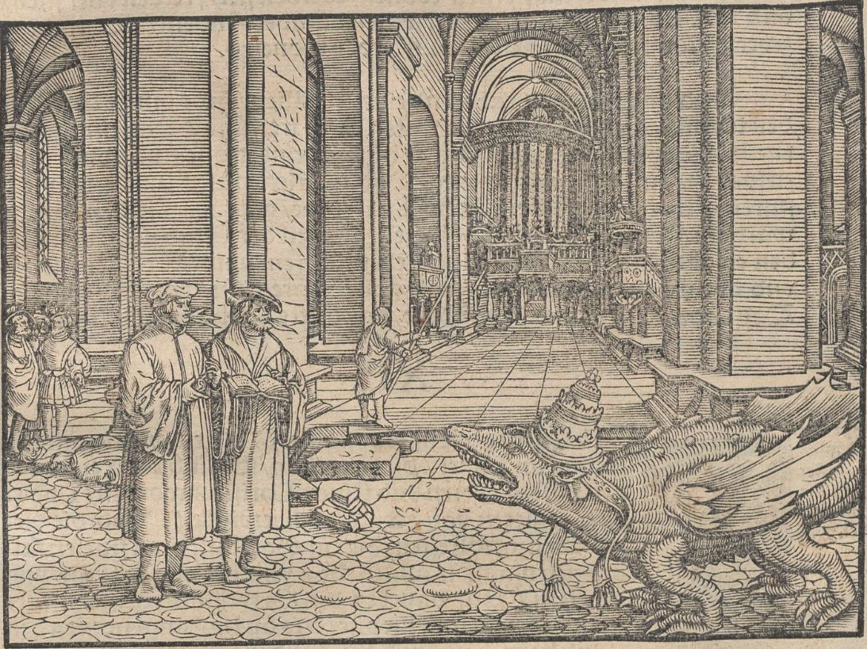

Two Witnesses and the Beast from the Abyss – Luther Bible woodcut

v. 7-10 – the two witnesses, upon completing their testimony, are killed by the beast[363] which comes[364] from the Abyss.[365] While the angel of the abyss and his hordes afflict the unbelieving world in 9.1-11, in chapters 12 and 13 they afflict the church; that they kill the two witnesses here is later described in 13.7 as their given power to “make war on the saints and conquer them.”

While the natural assumption is to identify “the great city” of verse 8 as Jerusalem, given its specification of, “where their Lord was crucified,” a word of caution is in order: Not only is this city also symbolically called “Sodom and Egypt,”[366] but elsewhere in Revelation, John uses the term “the great city” to describe not Jerusalem, but the personification of God’s earthly enemy: the great whore, Babylon,[367] who is drunk on the blood of God’s saints and is geographically identified in Revelation as synonymous with Rome.[368]

Caird in his commentary describes this city in which the bodies of the faithful are killed and left exposed as being Rome, specifically, the Roman Empire, which is composed of many “peoples, tribes, languages, and nations” and includes Jerusalem during the time of Jesus [and John].[369]

“*Wherever the church is trodden underfoot* [and killed], *that place and its inhabitants are as evil before God as Sodom and Egypt*.”[370] The connected here between Sodom and Egypt with Jerusalem is that, in all three places, their sin and evil resulted in the complete wrath of God, to their destruction.[371] Even as evil appears to triumph, and the unbelievers show the great indignity to the saints of even denying them burial, God’s wrath will be unleashed against them, especially when Christ returns to earth, bringing with him the very saints that had been murdered.[372]

That their bodies are left exposed[373] for “three and a half days” is to again invoke the “three and a half years” which coincides with the 42 months and 1,260 days: the full time of trial and persecution in which the church undergoes, which is the same 1,260 days in which they prophesy. The same sinful world which hated and rejected Christ, hates and rejects his witnesses, and the brutal humiliation of the saints’ bodies before, during, and after death are a reminder of the world’s hatred towards them.[374] As John sees here, the two witnesses are dead and left unburied in the street, while the sinful inhabitants of the earth gaze at their dead bodies and celebrate.[375] Brighton notes that the death of the church in a location, and the silence which follows, is a warning that those who live there, they and their descendants will not have an opportunity to again hear the Gospel before it’s too late.[376]

v.11-12 – after lying exposed in the street for three and a half days, a breath of life from God enters into the bodies of the two witnesses.[377] To the fear of the unbelievers, they rise from the dead,[378] and following a voice from heaven saying “Come up here!” they went up to heaven in a cloud.[379]

Brighton relates this to the church on earth, although it appears dead, nevertheless the church will continue its earthly witness. Following the same course as Christ himself, their end will be the same: ministry, death, resurrection, and ascension to God’s heavenly glory.[380] Metzger sees this as being not a historical event, but symbolic, that though the church on earth often seems to be defeated, yet will live.[381] Poellot believes that this event takes place at the same time as the resurrection of the dead and the Final Judgment.[382] *“What a picture for the lost to carry into the everlasting hopelessness and despair of their own damnation! There will be no more room for repentance for them, no ‘second chance,’ for then time comes to an end.”[383]*

v. 13 – the glorification of the church (that same hour as the two witnesses are taken into heaven) is accompanied by a great earthquake[384] that destroys a tenth of the city and kills 7,000[385] people[386] – yet the survivors, terrified, give glory to God.

The earthquake (and the resulting damage and death associate with it) represent God’s wrath against those who harm his saints.[387] History is filled with the examples of nations and Empires which violently persecuted the church, even appearing to be victorious over it, yet the church remained while they fell into destruction and ruin.[388]

That the survivors give glory[389] to God, suggests that those previously enemies of the church and active persecutors (at least some of them), are converted by the church’s witness to Christ, and even by their martyrdom.[390] In connecting this repentance to previous actions of God’s wrath, Wright says, *“We should not mistake the powerful impact of the symbolism in verse 13. When God judged Sodom and Gomorrah, he might have spared it if ten righteous persons were found there (Genesis 18.32). Now, however, only one-tenth of the wicked city is to fall, and nine-tenths is to be saved. When God was judging Israel through Elijah, only seven thousand were left who had not bowed the knee to the pagan god Baal. Now, however, it is only seven thousand who are killed, and the great majority are to be rescued. Suddenly, out of the smoke and fire of the earlier chapters, a vision is emerging: a vision of the creator God as the God of mercy, grieving over the rebellion and corruption of the world but determined to rescue and restore it…”[391]*

That said, numerous commentators believe that the remorse they express is “*not in repentance and faith but as ‘the devils also believe – and tremble (James 2:19b)’*”[392] but rather is “*given by those who realize it is too late for their own salvation*.”[393] Ryrie takes the middle, saying that some may repent, but others here merely recognize God’s divine power but without personal repentance.[394]

v. 14 – John notes here that the second[395] woe has passed (the first was the demonic hordes afflicting mankind, the second was the great slaughter of the last battle), but the third woe, the seventh and last trumpet was coming soon.

Verses 15-19 – The Seventh Trumpet: The End (and Its Joy)

v. 15-19 – The seventh and last trumpet is blown,[396] and loud voices in heaven and the twenty-four Elders alike joyfully celebrate the End: that the world[397] has become the Kingdom of God and his Christ, and their reign over the earth will be forever and ever.[398] They celebrate God’s wrath, judging of the dead, rewarding of his faithful servants,[399] and for destroying the destroyers of the earth. God’s temple in heaven opens, revealing the Ark of his Covenant, accompanied by thunder & lightning, rumblings, and earthquake, and heavy hail.

This victory song celebrates the triumph of God and the Lamb over all the forces of evil throughout all creation,[400] including sinful humanity: while God has been reigning over the whole creation since the beginning, the sinful world was “occupied territory”[401] under the power of the devil,[402] and this celebration is that the creation has finally been liberated and become God’s once more.[403] As long promised, the world/whole creation is his and his alone again, as he reigns creation through his Anointed One.[404]

In praising God, the redeemed call him, “Lord God Almighty, who is and who was.” Whereas earlier in the Revelation God the Father identifies himself as he spoke as, “I am the Alpha and the Omega, who is and who was and who is to come, the almighty” (1.8), this final trumpet and God’s arrival to reign has brought to arrival and completion all the promises God made to his people, bringing all the “future promises” to completion and fulfillment; these promises are detailed later in the Revelation.[405] This is itself a powerful testimony that what is seen here is the End and the Second Coming: as his saints no longer need proclaim God as “who is to come,” is due to the fact that he has come; their joyful proclamation exclaims “the future is now.”

The victory song here was used by George Frederic Handel as the lyrics to one of the greatest pieces of music in all history: *The Hallelujah Chorus*, from his *Messiah.*[406] The great voices in heaven are not identified, but the 24 Elders are. The church, all raised from the dead,[407] rejoices in God reigning unopposed through all creation, while God judges and “destroys those who were destroying the earth,”[408] that is, the unbelievers who rejected Christ,[409] and ultimately all the forces of evil which destroyed that good creation of God and his creatures: sin and death. As Paul described that “the last enemy to be destroyed is death,”[410] this is the time and moment when death itself will die.[411]

The final verse notes that God’s temple is opened, and the Ark of the Covenant[412] was seen. Formerly residing only in the Holy of Holies,[413] upon which God resided upon the mercy seat between the cherubim,[414] the Ark itself and God’s immediate presence was available to Moses and the high priests only; access to the immediate presence of God was highly restricted, to the point that approaching the Lord at an unspecific time[415] carried the death penalty, even for the priests.[416] That the temple is opened and the Ark is plainly seen by all the redeemed, is a very Hebrew way of stating what Revelation later describes: that in the world to come, the saved will not only live in God’s immediate presence,[417] but even behold his face.[418] Per the words of God himself through Jeremiah,[419] this is *not* a teaching that the original Ark of the Covenant is safely stored in heaven and will be seen again, but is instead a revelatory description of God almighty dwelling with his people in a way which is completely inconceivable to the sinful redeemed still living on earth.[420] The Ark seen here does not represent the historic artifact known as the Ark of the Covenant, but rather the immediate access to God’s presence which his people will enjoy for all eternity.[421]

That this is accompanied by natural disturbances of earthquakes, thunder and lightning, is that such things frequently accompany God’s holy presence within creation.[422] This is also a final note that these events all occur on the Last Day, as God’s arrival at the end of the world, in Revelation, is accompanied by these things in each cycle of visions.[423] Metzger concurs, writing, *“Certainly this has all the appearance of the end of the age, with judgment of the dead and rewarding of the saints and all who fear God’s name, both small and great. If John had finished his book here, we would have considered it properly terminated. But since there are eleven more chapters, the author will now go back to an earlier stage and repeat some of the teachings that he had previously set before the reader…the sequence in which John’s visions are presented does not allow us to turn the book of Revelation into an almanac or time chart of the last days.”* [424]

That said, Hailey refuses to accept that this describes the End. He instead think that Christ coming here is akin to Christ telling those at Philadelphia he would “come quickly,” and argues that the judgment of the dead is not a reference to the resurrection and final judgment but instead “*On behalf of the saints, the dead in sin are judged*” without any elaboration, as he also says to “destroy those who destroy the earth” instead means “*to change for the worse…as evil dispositions corrupt minds.*”[425] This is a classic case of *eisegesis*, that is, where one takes their own ideas and reads them into the text, instead of allowing what the text says to form your ideas, which is *exegesis*.[426]

In a like manner, LaHaye takes an unforgivably, wretchedly inconsistent track in his interpretation of this passage: to maintain his chronology of the seven year Tribulation, he writes, *“The blowing of the seventh trumpet (which is the third woe) does not initiate anything on the earth…it merely introduces the next series of judgments, the seven bowls. Occurring exclusively in heaven, the scene introduces activities that project a meaning to the earth to be disclosed in subsequent chapters.”*[427] He then argues that what is described here is projected forward to the final chapters of Revelation (such as *destroying the destroyer of the earth* referring to the condemnation of Satan into the Lake of Fire in chapter 19).[428]

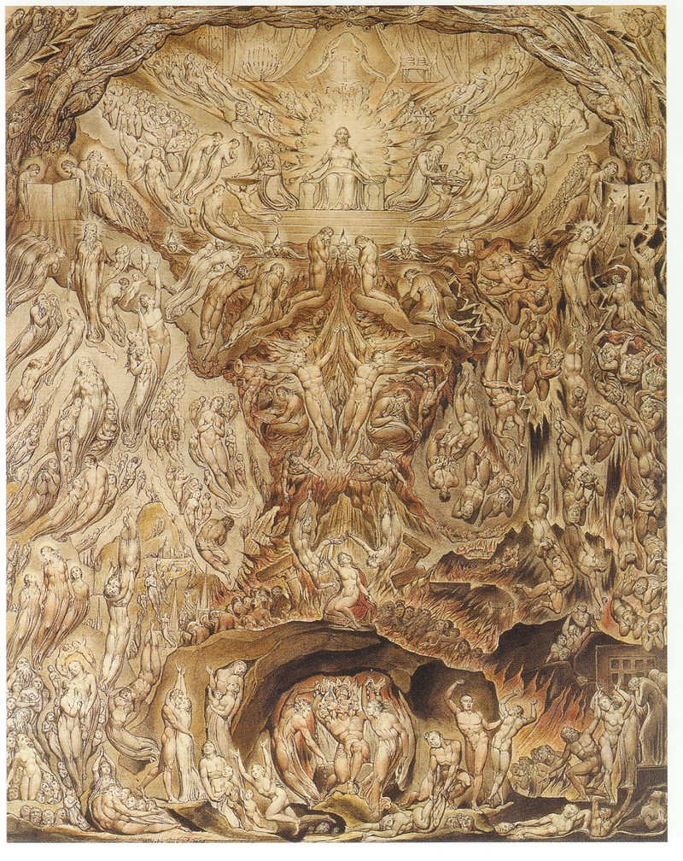

“The Final Judgment” by William Blake, 1808

Commentaries / Writers

Beckwith, Isbon T. *The Apocalypse of John*. Macmillan Company, 1919. [1843-1936, Episcopalian, American]

Brighton, Louis A. *Concordia Commentary: Revelation.* Concordia Publishing House, 1999. [1927-2015, Lutheran, British/American]

Caird, G.B. *A Commentary on the Revelation of St. John the Divine.* Harper & Row, 1966. [1917-1984, Congregationalist (Reformed), British]

Greene, Oliver B. *The Revelation: Verse by Verse Study*. The Gospel Hour, 1963. [1915-1976, Baptist, American]

Hailey, Homer. *Revelation: An Introduction and Commentary.* Baker Book House, 1979. [1903-2000, Churches of Christ, American]

LaHaye, Tim. *Revelation Unveiled.* Zondervan Publishing House, 1999. [1926-2016, Baptist, American]

Metzger, Bruce. *Breaking the Code: Understanding the Book of Revelation*. Abingdon Press, 1993. [1914-2007, Presbyterian, American]

Poellot, Luther. *Revelation: The Last Book in the Bible*. Concordia Publishing House, 1962. [1913-2006, Lutheran, American]

Ryie, Charles Caldwell. *Revelation.* Moody Press, 1968. [1925-2016, Baptist, American]

Tenney, Merrill C. *Interpreting Revelation.* William B. Eerdmans Publishing Company, 1957. [1904-1985, Evangelical, American]

Unjhem, Arne. *The Book of Revelation.* Lutheran Church Press, 1967. [ , Lutheran]

Wright, N.T. *Revelation for Everyone.* Westminster John Knox Press, 2011. [1948- , Anglican, English]

1. Metzger helpfully summarizes these chapters as follows: the first four seals are opened at once, together making one picture. The fifth and sixth seals together make one picture, and then intermediate material leads to the opening of the seventh seal, which in turn, introduces the next series of visions. The trumpets more-or-less repeat the seals, but from God’s standpoint: the first four trumpets give a unified impression, the fifth and sixth give a unified impression, and then intermediate material leads to the seventh trumpet. – Metzger, 55.
2. Beginning here and through the end of Revelation 16, John sees three visions which cover the whole of history from the Ascension of Christ to his return at the End – the Seals, Trumpets, and a series of seven of which the seventh is itself the seven Bowls/Censures (per Poellot). All these visions run concurrently, but three sections especially are noteworthy in their similarity: the seven seals, trumpets, and bowls, and each of these three visions contains seven scenes: the first five scenes in these three visions cover the period from the Ascension to the last great battle (called *Armageddon*, in 16.16). The sixth scenes in the second and third visions cover this great battle (whereas the first vision skips this battle). The sixth scene in the first vision pictures the End itself, whereas in the second and third visions, the seventh scene pictures the End. Covering the same period in history, these visions are concurrent with one another, and while they are not given to help predict specific events in history, they do portray the conditions, situations, environments and contexts in which earth and its people find themselves.

   Metzger notes that covering the same material repeatedly, but emphasizing one or another aspect of the whole, is a not a product of the strictly logical Western mind, but of the Semitic. – Metzger, 56.
3. LaHaye, while noting that many Bible teachers see the Seals, Trumpets, and Bowls occurring concurrently, rejects this and assumes that they must occur chronologically – and specifies that the seal judgments all occur within the first twenty-one months of the seven year tribulation – LaHaye, 141. Ryrie agrees that they are not concurrent but follow one another in sequence, but does not give a time frame for the sequence in his commentary.
4. Brighton notes, *“The four horsemen…are symbols that are taken from common human experience and thus are used to symbolize and represent that which is of this world and understandable within human knowledge and experience.”* Brighton, 161. Even LaHaye, known for taking much of Revelation literal to a confounding degree, admits *“It is not God’s intent to convey individual personality through these horsemen but world conditions…The four horsemen present the picture of man’s inhumanity to man.”* LaHaye, 141. Wright notes, *“These four are the basic ills which humans inflict upon one another. They charge off around the world, and must be allowed to do this that the save message of the scroll can have its full effect…if God’s new creation is to be brought to birth, the deepest ills of the old one must be exposed, allowed to come out, and be dealt with.”* Wright, 62.
5. For instance, the Metallica song “*The Four Horsemen*” identifies them as Time, Famine, Pestilence, and Death. The *Robot Chicken* “*My Little Apocalypse Pony*” sketch presents them as Pestilence, Famine, War, and Death.
6. Bizarrely, Greene claims that the voice directing John to behold the first horseman is “none other than Jesus.” Greene, 192.
7. Whereas the KJV has the repeated phrase “Come, and see” coming from all four living creatures, the oldest and best copies of Revelation all lack “and see” (and thus the phrase is missing from the NASB, ESV, 1984 NIV, etc.); as John is already in a position to see all that will follow, the *erchou,* “come” is not the living creatures speaking to John, but to the horsemen, and can equally be translated instead of “come!” as “go!”
8. Rome and Parthia fought a series of wars from 54 BC – 217 AD. While Rome was consistently the aggressor, they never both conquered *and* kept Parthian territory. Shortly before the receiving of the Revelation, Rome and Parthia fought a war over the buffer state of Armenia in 58-62 AD, which ended in an effective stalemate and saw numerous heavy Roman losses, especially leading up to & the siege of Rhandeia, where an army of two Roman legions were defeated, stripped of clothes and weapons, and as terms of surrenders, agreed to abandon all town and forts in Armenia as they withdrew.
9. Metzger notes that the Parthians viewed the color white as sacred, and interprets this first rider as indicative of a coming successful Parthian invasion (but does not note when that invasion took place). Metzger, 58.
10. Irenaeus, *Against Heresies* Bk 4 and Victorinus, 3rd century Latin commentary on Revelation.
11. White as a heavenly color and representing holiness, such as the white robes which God gives his saints.
12. See Habakkuk 3.8-13 (specifically verses 8 & 9); Psalm 45.5.
13. Hailey, 189.
14. Poellot, 94.
15. For instance, 1 Samuel 31.3, 1 Kings 22.34, Psalm 11.2 & 18.34, Jeremiah 6.23 & 50.42.
16. Psalm 46.9; Zechariah 9.10
17. Caird notes that some commentators hold that this is not Christ himself, but the victorious proclamation of the Gospel, given the similarity to Christ himself in c. 19, but also because in the Olivet Discourse (Mark 13.10), Christ stated that the preaching of the gospel to the whole world is, along with war, famine, and persecution, one of the inevitable preconditions of the coming of the End. – Caird, 80.
18. Brighton, 165.
19. While John wrote that “Antichrist is coming, and even now, *many antichrists* have come” in 1 John 2.18, the final, major enemy of God’s people is mentioned as “the man of lawlessness” in 2 Thessalonians 2.3-4, and in Revelation, as either the Beast out of the Sea (13.1-10) or the Beast out of the Earth (13.11-18).
20. 2 Corinthians 11.14
21. As mentioned above, Christ is depicted as a conquer on a white horse wearing a crown in Revelation 19.11-16. Greene identifies this rider as the antichrist, carrying a bow (but now arrow) because he conquers bloodlessly; his pre-millennial dispensationalist belief requires an antichrist peacefully conquering the world for 3.5 years before “all hell breaks loose,” 193-194.
22. Brighton dismisses the notion of the Antichrist as the first horseman. He reasons that, in Revelation, the antichrist is best described by the Beast out of the Earth (13.11-18; this is the beast which performs miracles and has “two horns like a lamb” in its imitating of Christ) and is later depicted as the Whore of Babylon (chapters 17-18). He connects the first horseman with the Beast out of the Sea (13.1-10) as both wearing crowns and thus sharing their identity, while also noting that the Beast out of the Sea and the Whore of Babylon are never depicted as wearing crowns.
23. LaHaye then launches into a tirade against both the United Nations and Socialism, (LaHaye, 142-143) and in his *Left Behind* series, the Antichrist, Nicolae Carpathia, is depicted as seizing world power via the UN. Ryrie agrees that this is the Antichrist who conquers bloodlessly, at least at first, given that war is not revealed until the second seal is broken. Ryrie, 45.
24. Such as in 12.7, where the word for war, *polymos* is used.
25. Per Romans 13.1-8, the governments bear the sword against the criminals, but this would cover all murder & bloodshed that is done by, for instance, criminals, gangs, cartels, and rebels in their desire to accomplish whatever goals they may have, be it rioting, racial hatred, government overthrow, or acquisition of stolen goods via violent means.
26. Matthew 24.6-10; Mark 13.7-9; Luke 21.10-16
27. LaHaye, 144.
28. Matthew 10.16-22
29. Matthew 10.34
30. Matthew 10.35-39
31. In Jeremiah 14.1-2, in describing this time of famine/drought, the gates of Judah are literally “darkened to black” in both the Hebrew and LXX.
32. Green interprets these verses as the suffering of the working classes and poor, while the rich, governing classes will be exempt, only to receive punishment from God later, p 200-201.
33. Assuming that John received the Revelation in AD 95, this was only three years after a serious grain famine afflicted the Roman Empire in the year 92.
34. Beckwith notes that, in Rome during the time of Cicero, a denarius/day’s wage could buy twelve measures of wheat, with barley costing half as much, and during the time of the apocalypse, the relative cost of these two grains was 3:1. This horsemen thus presents inflation at 12x for wheat and 24x for barley – Beckwith, 520. Metzger’s numbers differ slightly, noting that a denarius would usually buy between 8x and 16x as much grain as mentioned here – Metzger, 58.
35. Even after the success of “the Father of the Green Revolution” Norman Borlaug from the late 1960s – late 1980s, there have been over three dozen famines in Africa and Asia, caused by tyrants and drought, some of which resulted in the deaths of millions; the Second Congo Civil War (1998-2004) killed 2,700,000, primarily due to starvation and disease. This pales in comparison to the Great Chinese Famine under Mao Tse Tung from 1958-1962, in which upwards of 55,000,000 Chinese died of starvation. But of course, during these famines, the leaders of those governments were consistently and luxuriously well-fed: Chairman Mao literally grew fat (and fatter) as millions of Chinese were starving to death – akin to Kim Jong-Un in our own time, who is overweight while most North Koreans are underfed. For an American example, in 1932, during the height of the Great Depression in the US, President Herbert Hoover was recorded feeding a T-bone steak to his dog.
36. As did the Samaritan to the man set-upon by robbers in the Parable, Luke 10.34.
37. Hailey, 191-192.
38. The other times are: 9.13, 10.4 & 8, 11.12 & 15, 12.10, 14.13, 16.17, 18.4, 19.5, and 21.3.
39. This is the only rider among the four given a specific name. As the Greek word *Thanatos* was used in some places in the LXX as the word for “pestilence” (Leviticus 26.25, Jeremiah 14.12 & 24.10), this is the origin for the ever-recurring “Pestilence” horseman.
40. Hades initially was only used as the name of the Greek god of the Underworld, but later became a term to denote the whole of the underworld itself; like Sheol to the ancient Hebrews, it was synonymous with “the grave” and to it all the dead went, both the righteous and the wicked. Later on in Judaism, “Hades” was used only to specifically describe a place of only torment and punishment for the unrighteous dead. LaHaye argues that Hades being mentioned here means that all those killed by the horsemen are “unsaved dead,” as dead believers don’t go to hell. LaHaye, 145.
41. LaHaye confidently asserts that ¼ of humanity will be killed during the first 21 months of the Tribulation, apparently given the description of the Horsemen having authority over “a fourth of the earth.” LaHaye, 145.
42. Ryrie interprets this to indicate that, rather than a fourth of the earth being afflicted, a fourth of the population of the earth is killed, 46.
43. Whereas Hailey identified the first three horsemen as being explicitly Christian in their message of Gospel-Persecution-Hardship, he identifies this horseman as death – specifically, God’s judgment against the world of unregenerate people (those who reject the Gospel), but with such widespread suffering and destruction, Christians would necessarily suffer along with the rest. Hailey, 193.
44. The KJV confusingly rendered “pestilence” here as “death,” so that Death and Hell killed with sword, hunger, death, and beasts of the earth.
45. Metzger, 57. He later notes that “*God does not will the woes, but as long as we are free agents God allows them,”* p. 58.
46. Zechariah 1.7-17
47. Zechariah 6.1-8
48. For instance: war and famine: Judges 6.1-6; disease: Numbers 12.9-15; wild beasts: 1 Kings 13.20-24
49. Wright, 62-63.
50. The Greek indicates that this is the altar of incense (same word used in Luke 1.11, where Gabriel appeared to John the Baptist’s father Zechariah). It should not be difficult to accept that there is an actual incense altar before God in heaven, as Moses’ instructions on building the tabernacle were given by God with specific dimensions to be followed exactly, as the earthly one was to be a copy of the true one in heaven – see Hebrews 8.5.
51. An interesting speculation here is whether John saw individuals here, which would have included (just from his own lifetime and experience) John the Baptist, all the other apostles of Christ, Stephen, James the brother of Jesus, Paul, and Antipas.
52. While the KJV renders this as “testimony,” the Greek word is *martyrian,* which means “witness” and itself became the origin of the word Martyr.
53. Wright, 65.
54. Caird, 84
55. God’s “delay” of the wrath and final judgment of the Last Day is his patience and desire to save: 2 Peter 3.3-10. But this “how long” also suggests that this was not the beginning of the struggle, but had been going on for some time.
56. Christians are prohibited from seeking vengeance (Leviticus 19.18; Romans 12.19), but innocent blood cries out to God from the ground (such as with Abel in Genesis 4.10), and asking God to take vengeance on the wicked is commonly spoken in the Psalms (such as, for instance, 3.7, 68.6-11, 79.10, 94.1-6, *et al.*)
57. Brighten quotes another theologian to soften the force of this statement, who wrote, “*This request does not rise from a personal desire for revenge, but out of concern for the reputation of God.*” Brighton, 170. Caird writes, “*The point at issue here is not the personal relations of the martyrs with their accusers, but the validity of their faith. They have gone to their death in the confidence that God’s word, attested in the life and death of Jesus, is the ultimate truth; but unless in the end tyranny and other forms of wickedness meet with retribution, that faith is an illusion.”* Caird, 85. Wright notes, *“This is not petty or spiteful vengeance, but the heartaching desire to see the world brought back into balance at last, and their own harsh verdict and sentence being shown up as unjust.”* Wright, 66.
58. As did the blood of Abel following his murder at the hands of Cain, Genesis 4.10
59. Genesis 9.5-6; Numbers 35.33
60. Deuteronomy 32.43; Joel 3.19-21; 1 Corinthians 3.16-17
61. Matthew 26.39; Mark 14.36; Luke 22.42
62. Exodus 30.7-8, 40.26-28; Psalm 141.2
63. Revelation 1.6, 5.10, 20.6
64. Revelation 15.2-4
65. Helpfully, Wright suggests that how a ‘soul’ puts on a ‘robe’ might baffle the imagination, but reminds that John is writing in symbols, and the white symbolizes victory and purity – Wright, 66. As described earlier by Metzger, “*Revelation doesn’t mean what it says, it means what it means*.”
66. This happens in baptism – see Galatians 3.27, Ephesians 4.24, Colossians 3.10-14
67. Revelation 7.14
68. Translated in the KJV as *“a little season,”* literally, *chronon micron.* This is the same term used to describe the brief period of Satan’s activity on earth just before his final doom (20.3)
69. The estimated number of Christian martyrs currently stands at, at the lower estimate 70,000,000 (with the upper estimate around 100,000,000) at the hands of, primarily, Jews, Romans, Muslims, Buddhists, and Atheists. An estimated 35,000,000 were killed in the 20th century alone, due to the actions of the Ottoman Turks in the Armenian Genocide, a worldwide resurgence of fundamental Islam, the spread of Communism (just in the Holodomor, a Soviet-engineered famine in Ukraine during the winter of 1932-1933, between 4 - 8 million were killed), and the Nazis, who killed an estimated 1,900,000 Christian Poles from 1939-1942.
70. John 5.22-27; Acts 17.31; Revelation 19.11-21, 20.11-15.
71. LaHaye, 146; Ryrie, 46-47.
72. Haggai 2.6-7 // Hebrews 12.26-28
73. Zechariah 14.5
74. Isaiah 13.10; 50.3; Amos 5.18-20; Matthew 24.39
75. Joel 2.30-31
76. Matthew 24.39; Isaiah 34.4; the “winter fruits” of figs grow during winter and do not ripen to maturity, but dry up, shrivel, and fall to the ground during the spring winds.
77. Isaiah 34.4
78. Isaiah 54.10; Ezekiel 38.20; Nahum 1.5
79. Hosea 10.8; repeated by Jesus on the way to the cross, as he pointed ahead to Jerusalem’s destruction, itself a type/preview of the end of the world – Luke 23.30
80. This is a quotation of Malachi 3.2
81. Poellot, 101.
82. Isaiah 2.10-22
83. Biblically, the term “Great Day” harkens back to a multitude of promises described as the “(Great) Day of the LORD,” that of the Almighty’s wrath [anger & judgment] against sinful mankind – Joel 2.11, 31; Amos 5.18-20; Obadiah 15; Zephaniah 1.14-2.3; Malachi 4.5-6; Romans 2.5; 1 Thessalonians 5.2; 2 Peter 3.10; Jude 6, et al.
84. Hailey, 197.
85. Such as Isaiah 13.10 & 34.4; Jeremiah 4.23, Joel 2.31; this ignores the obvious Biblical teaching of *Types*, where small examples can be made which point ahead to much greater realities to come, namely how Christ used Jerusalem in the Olivet Discourse to point to the Second Coming.
86. Hailey, 197-199.
87. Ryrie, 48.
88. Oddly enough, this came not from Brighton’s commentary, or any other commentary I’ve read, but from an online Revelation Bible study uploaded by an LCMS Pastor in Texas: Rev. Dr. Laurence White of Our Savior, Houston; p. 144.
89. This interlude is seen by John between the sixth and seventh seals; a reasonable explanation for this interlude being placed here is that, following John’s witness of the world ending and its terror, the Lord gives John an interlude of comfort, peace, and joy, before then returning to God’s wrath and punishment of a sinful world. It also gives an answer to the question raised at the end of chapter six: “Who can stand?”
90. For instance, Jubilees 2.2: “*the angels of the spirit of fire, and the angels of the spirit of the winds, and the angels of the spirit of the clouds and darkness and snow and hail and frost, and the angels of resoundings and thunder and lightning, and the angels of the spirits of cold and heat and winter and springtime and harvest and summe*r.”
91. Specifically, Jeremiah 49.36-39; see also Daniel 7.2-3, where the four winds of heaven stirred up the sea, out of which four great beasts then emerge, all of which were seen as enemies of God’s people. The Lord is also depicted as riding on the wind (Deuteronomy 33.26; Psalm 104.3), at times with the purpose of judgment (Psalm 18.10)
92. Greene believes this angel is Jesus. Greene, 268.
93. Ezekiel had seen the glory of the LORD depart from the temple in Jerusalem by the east gate (Ezekiel 10.18-19) prior to its destruction, and prophesied that the glory of God would return from the east and re-enter the temple via the east gate (Ezekiel 43.1-4).
94. Wright points out that one of the many tantalizing features of Revelation is that we are never told when these winds blow, or what happens when they do. Wright, 71.
95. Such as in Jeremiah 49.36-38, where the winds of God’s judgment and warfare are to be unleashed on Edom.
96. Namely Clement of Alexandria and *The Shepherd of Hermas*.
97. Origen, for instance, believed the seal to be the name of Jesus and of His Father.
98. Ephesians 1.13-14; 2 Timothy 2.19
99. In Revelation 9, those with the seal of God upon their foreheads were spared from the locust/demons which come out of the Abyss to afflict mankind.
100. The faithful were to be sealed with a ת (a Tav, which is the same word for “mark”), which in 5th century BC Hebrew, would have looked like an X, or a cross; the LXX used the word *saymion* (sign), indicating that this was, in some way, a visible mark.
101. Ezekiel 9. For another example of God sealing his people with a sign to spare them from impending divine judgment, see the Passover in Exodus 12.12-13
102. In our baptism Liturgy, it is not without reason that, towards the beginning, the Pastor states, “*Receive the sign of the holy cross both upon your forehead and upon your heart, to mark you as one redeemed by Christ the crucified.”* LSB 268.
103. Given Hailey’s prior interpretation of the second horseman, his interpretation here is odd.
104. Wright, 70.
105. That these sealed are the Church Militant on earth is made clear by their re-appearance with Christ in Revelation 14.1-5, and that they are described as following Christ in context of events which take place on earth.
106. This includes Victorinus (3rd century, Latin), Oecumenius (6th century, Greek), & LaHaye (20th century), onward to Greene, who maintains 144,000 Jews will go out speaking in other tongues, just like at Pentecost, and LaHaye, who insists they will be literally 12,000 Christianized Jews from each of the listed twelve tribes, reaping a massive soul harvest. Ryrie too maintains these cannot be any other group of people other than Christianized Jews.
107. For instance, Paul describing Christians as the “true Israel of God” and “true sons of Abraham” in Romans 4.1-12, 9.6-8, 11.11-27; Galatians 3.26-29, or James’ letter to Christians, addressing them as “the twelve tribes in Dispersion” in James 1.1
108. Recall Revelation 3.9, where the unfaithful Jews are referred to by Christ as “the Synagogue of Satan” and are identified as “those who claim to be Jews but are not.” Thus, those in the Church are the “true Jews.”
109. This helps solidify the “Church Militant” claim, as these followers are “male” and “consecrated virgins,” suggesting a devout, highly-focused military force that will not be misled by earthly distractions (such as, as often occurs in warfare, sexual liaisons, willing and forced, with local women).
110. As Metzger describes it, *not one of the redeemed is missing.* P. 61.
111. Recall that, during the Exodus, the twelve tribes were arranged in battle formation following the Ark as they moved from place to place, with specific tribes in specific marching order (Numbers 10.11-28). They likewise kept a specific deployment when encamped around the Tabernacle (Numbers 2.1-31): with three tribes facing each cardinal directions, this same arrangement is later used as the 3 gates facing each direction, with the names of the twelve tribes upon each gate, in the New Jerusalem (Revelation 21.12-13).
112. In describing the New Jerusalem, the walls are 144 cubits thick, with 12 foundations of 12 precious jewels (named after the 12 apostles), 12 gates (named after the 12 tribes) and manned by 12 angels (Revelation 21.10-21).
113. Caird, 95.
114. Levi received cities scattered among all the Promised Land, but among the tribes they alone had no territory of land. The half-tribes of Ephraim and Manasseh, named after Joseph’s sons, both received land allotments.
115. Leshem was outside the Promised Land, in the region of Sidon. As God had previously warned the Israelites that they would not be given land allotted to other nations outside the Promised Land without his express permission (such as the land belong to Esau’s descendants, the Moabites, or the Ammonites remaining theirs – see Deuteronomy 2.2-19), them seizing their neighbor’s territory by slaughtering its peaceful inhabitants was a terrible deed.
116. 1 Kings 12.25-30
117. *Against Heresies*, Bk V, c. 30, citing Jeremiah 8.16 to support his position. Metzger notes that the association of Dan with the Antichrist can be traced as far back to Genesis 49.17. Ryrie maintains that, as Ezekiel saw land being given to Dan in the future (Ezekiel 48.1), he maintains that the Danites will still somehow be saved and receive land in the Millennial Kingdom – Ryrie, 52.
118. Judges 17.1-13
119. 1 Kings 11:26
120. For comparison’s sake, 144,000 is smaller than the population of Columbia, Missouri, whereas the number of self-professing Christians in Missouri alone is over 4.5 million (as of 2024).
121. This “countless” host of the redeemed goes back to the promises God made to Abraham, of descendants as numerous as the stars of the heavens and the sand on the seashore (Genesis 22.17; Hebrews 11.12).
122. Brighton argues in his commentary that John is seeing here not only the redeemed souls in heaven, but the complete church in its eschatological state, already triumphant and complete, as it will be seen after the resurrection – Brighton, p 200.
123. Contrary to what Ryrie has written, this does not indicate that “there are no tears in heaven,” but that God will wipe away every tear.
124. Following the twenty-four elders in 4.4 and the martyrs under the altar in 6.11. Note that to the Christian in Sardis, Christ promises that white robes are *given* to the faithful.
125. Per Revelation 7.14; also 5.9 & 12.11
126. As this is a vision given to John, it is best to not get caught up on the logical question of, “How can a soul wear a white robe or hold palm branches in their hands?” Per Metzger’s commentary, p. 26, “*It may seem paradoxical to say that the description does not mean what it says; it means what it means*.” Also, see footnote 71 for another explanation.
127. 1 Kings 6.29-35
128. Ezekiel 40.16-37, 41.18-26
129. Leviticus 23.40-43; Nehemiah 8.13-17
130. 2 Maccabees 10.5-8,
131. Matthew 21.8 & Mark 11.8 record “branches from trees/leafy branches,” but John 12.12-13 specifies they were branches of palm trees.
132. Specifically in the Greek, an *Oday,* or Ode.
133. V. 8 is sung by the living creatures to God the Father, and verse 11 by the twenty-four elders before the throne, again to God the Father.
134. v.9 & 10 are sung by the four living creatures and twenty-four elders, with the stanza directed at Christ. In verse 12, the angels around the throne sing to Christ, and in verse 13, every creature in creation (heaven, earth, under the earth, the sea) sings to both the one sitting on the throne [God the Father] and the Lamb.
135. An Elder asks John a rhetorical question; John’s reply allows the Elder to expound on the blessedness of the redeemed. Those holding to a rapture and its associated chronology (such as LaHaye and Ryrie) claims in their books that John was “confused” and “didn’t recognize these saints,” as evidence that these are those saved after the rapture, during the Tribulation thanks to the preaching Jews, and are not the redeemed saints of the church prior to the rapture.
136. Along with 5.5, when an elder pointed out the Lamb, this is the only other place where John has one of his fellow redeemed explain anything to him – usually it is an angelic mediator, or in some cases, Christ himself.
137. In the Greek, *tays thlipseows tays megalays,* literally, “The Tribulation, the Great [one]”
138. Revelation 6
139. Which would include the martyrdoms of Stephen and James in Acts, the martyrdoms of Peter and Paul under Nero, the martyrdom of Antipas and exile of John on Patmos, etc.
140. Specifically, Matthew 24.15-31/Mark13.14-27/Luke 21.20-28
141. Matthew 24.21
142. Matthew 24.22
143. Greene, 229-230. For instance, he argues “the sun will not strike them” as them remaining underground to avoid the Antichrist and his sanctions against those without the mark of the beast. LaHaye agrees that this multitude is limited to those converted by the 144,000 evangelical Jews, but after conversion have been killed and are in heaven.
144. Hailey, 210.
145. Also Revelation 15.2-4; Romans 3.21-26; Hebrews 4.14-16; 1 John 1.7-2.2, *et al*.
146. John 1.12-13; Ephesians 2.1-9. To emphasize that the faithful cannot do anything to obtain the forgiveness of sins, see Jeremiah 2.22; Job 9.30-31.
147. John 15.1-5, *et al*
148. Isaiah 64.4: our righteous deeds are like a polluted garment (literally in the Hebrew, *a used menstrual cloth*).
149. Ephesians 2.10: we are saved by grace through faith and not by works, *so that* we can do the good works God has prepared for us to do. This is also the context behind James 2.14-18.
150. Matthew 7.21, 12.33-37, 25.14-30, *et al.*
151. 1 Corinthians 3.10-15; 2 Corinthians 5.10
152. Literally in the Greek, “*the one sitting on the throne spreads his tent over them*”
153. Christ speaks of those who come to him as never again experiencing hunger or thirst, John 6.35
154. See Isaiah 49.8-10, where God also promises his people an existence without hunger, thirst, or striking sun.
155. Such as fire: a good promise, considering how many Christians in Rome were martyred as “Roman candles” by Caesar Nero.
156. Ezekiel 34.11-16; Psalm 78.52; Jeremiah 31.10-11; Micah 7.14; John 10.11-14
157. See Revelation 21.6
158. See Revelation 21.4
159. Jeremiah 31.15-17; John 16.20-22
160. Caird poetically describes this silence as, “*It is though there is one bar’s rest for the whole orchestra and choir of heaven before they launch on the second of John’s symphonic variations.”* Caird, 106. Hailey writes, “*Let the reader keep in mind that the book is a revelation of the fortunes of the church in the world and the destiny of the world as it opposes the church. The climax is judgment and a revealing of the invincible power of the Christian’s secret weapon: the divine response to the prayer of faith. The Father watches over His own; He hears their petitions and responds with action. As in ancient times when His people were threatened with invasion and destruction by the great pagan power of that day, Babylon, the Lord’s promise was, ‘Jehovah is in his holy temple; let all the earth keep silence before him’ (Hab. 2:20). From that temple He then assured His people of His coming in power to bring salvation to them and judge the enemy (Hab. 3). And now, from heaven’s viewpoint it is revealed what is about to happen, and all heaven is quiet with a deathlike silence. ‘About the space of half an hour’ indicates dramatic suspense. A half hour is ordinarily a short period of time, but it seems long when one is waiting. The impressive pause focuses attention on heaven’s interest as all wait in breathless suspense and expectation for what is to follow.”* Hailey, 214-215. Wright writes, *“If we were expecting something even more spectacular than the great display of praise and worship around the throne, we might be disappointed by this sudden silence. But the unexpected hush in heaven ought to tell us that something huge, something powerful, something utterly decisive, is now going to happen.”* Wright, 78.
161. Hebrews 4.1-11
162. Genesis 2.2
163. 4 Ezra 6.39 describes darkness and silence covering everything before God spoke the words “Let there be light”; 2 Baruch 3.7 says there was silence at the original creation.
164. 4 Ezra 7.30-36
165. Wisdom 18.14-19
166. Immediately following the seventh seal (and its silence), the first four trumpets will sound to inflict great suffering upon the earth.
167. Metzger, 62.
168. Greene, 232.
169. LaHaye, 163.
170. This is not the first use of seven trumpets carrying the wrath of God in the Bible; it was seven priests blowing seven trumpets which signaled the destruction of the wall of Jericho (Joshua 6.4, 20) and its subsequent sacking.
171. *Tous*, the masculine plural of Greek definite article “the”
172. Hailey argues that the seven should not be taken literally, but notes that it represents completeness, 215.
173. 1 Enoch 19.1-20.7 gives their names and duties: Uriel, Sariel, Raphael, Raguel, Michael, Remiel, and Gabriel; 4 Ezra 4.36 lists Jeremiel/Remiel, whose name is added to the end of 1 Enoch 20 in a variant Greek manuscript, which would then exclude Uriel as one of the seven.
174. Tobit 12.12-15
175. Daniel 10.13 & 21, 12.1 (where he is called “Great Prince” in Aramaic and “Great Angel” in the LXX, most likely the origin for the term *archangel*); Jude 9; Revelation 12.7
176. Daniel 8.16, 9.21; Luke 1.19, 26. Gabriel tells Zechariah that “I stand in the presence of God.” An “angel of [God’s] presence” saved his people according to Isaiah 63.9. Based on Gabriel’s words, LaHaye is confident that one of these seven is Gabriel – LaHaye, 164.
177. Brighton argues that these seven angels who blow the trumpets, the seven angels of the seven churches, and the seven angels with the bowls/censures of God’s wrath, are the same seven angels, doing multiple duties – Brighton, 216-218
178. Brighton does not, and argues (without expanding upon why) that they shouldn’t be identified as such – Brighton, 218.
179. Greene uniquely (and bizarrely) identifies this angel as Jesus Christ, on the basis that the prayers ascend *from the angel’s hand*, p. 239.
180. Censers have been used in Christian churches from ancient times until now, and are found in some Lutheran churches: they are ornate incense burners which hang on a short chain, and release the smoky incense during worship as the Pastor or an assistant swings the censer back and forth.
181. This would include all the saints *on earth*; i.e., by New Testament definition, living Christians are saints: Romans 1.7, 16.15; 1 Corinthians 1.2; 2 Corinthians 1.1; Ephesians 1.1; Philippians 1.1; Colossians 1.2; 1 Timothy 5.10; Philemon 1.5, etc. This verse in no way suggests that Christians are to invoke the angels and saints of heaven to pray for us on our behalf, as our prayers arise directly to God – Poellot, 116.
182. LaHaye believes that these are the prayers of the past 2,000 years for God to avenge himself on those who blaspheme him and abuse his people, saved up for this moment – LaHaye, 164.
183. Theoretically, the same altar under which the martyrs cry out for vengeance (6.9): an incense altar.
184. Brass censers at the Tabernacle (Exodus 27.3), golden censers at Solomon’s Temple (1 Kings 7.50).
185. Exodus 30
186. Psalm 141.2
187. Ezekiel 10.2, 6-7
188. For instance, at Sodom and Gomorrah (Genesis 19.24-25); Leviticus 10.1-2; Numbers 16.35; Malachi 4.1
189. Thus Wright, *“as long as earth remains the haunt of evil, [God’s] answer to it must be fire. Jesus himself declared that he had come ‘to throw fire upon the earth’ (Luke 12.49). Here the angel with the golden censure continues the lamb’s strange work.”* Wright, 80.
190. In that Christ gave John the seven letters and broke open the seven seals. Christ is still visible from 8.6 onward, but doesn’t speak directly to John, nor does Jesus blow one of the seven trumpets or pour out one of the seven bowls/censers of God’s wrath upon the earth.
191. It is still Christ’s revelation, and his breaking the seventh seal shows he’s still the one in charge, but the duties of conveyance to John have shifted to angels from this verse and forward to 22.6, at which point Christ resumes speaking to John directly.
192. For instance, Genesis 18.1-2, 21.14-19, 32.24-30,; Exodus 3.1-4; Joshua 5.13-15; Judges 6.11-16, 13.3-11
193. Acts 7.38, 53; Galatians 3.19; Hebrews 2.2
194. Exodus 33.18-20; see also Revelation 1.17, where the exalted Christ’s appearance results in John falling to the ground as though dead, and the Transfiguration, where Peter, James, and John fell on their faces and were terrified (Matthew 17.7). Likewise Christ’s appearance to Saul on the Damascus Road, where the blinding brightness of God resulted in Saul being unable to see (Acts 22.11).
195. Brighton, 207-208
196. Brighton argues that, given the “*unique and esoteric character of the message of Revelation*,” it was necessary for Christ himself to establish that the Revelation is from him and fully authoritative by himself mediating the first part of it – only after this reliability is established, could Jesus “*safely turn over*” the rest of the message to angels, knowing that John would continue to receive it from the angels as from Christ himself – Brighton, 208-209.
197. Zephaniah 1.14-16
198. Zechariah 9.14
199. Isaiah 27.13
200. Matthew 24.30-31
201. 1 Corinthians 15.52; 1 Thessalonians 4.16
202. Hailey, 218.
203. The four horsemen are given power over a fourth of the earth, but it is not specified that a fourth of the world’s population dies by their hand – but in fact, until Christ returns, death has claimed every human life to ever live, Jesus of Nazareth’s included, save for Enoch and Elijah.
204. Caird harshly but accurate writes, “*Modern readers are apt to be shocked at the idea that God should be prepared to kill off large numbers of men in order to provide an object lesson for those who survive. John is more realistic about the fact of death. All men must die, and the question mark which death sets over their existence is just as great whether they die late or soon, alone or in company, violently or in their beds. Their ultimate destiny is not determined either by the moment or by the manner of their death, as ultimately the death of the martyrs should prove, but by the opening of the heavenly books and by the true and just judgments which proceed from the great white throne. The idea that life on earth is so infinitely precious that the death which robs us of it must be the ultimate tragedy is precisely the idolatry that John is trying here to combat. We have already seen that John calls the enemies of the church ‘the inhabitants of the earth,’ because they have made themselves utterly at home in this transient world order. If all men must die, and if at the end heaven and earth must vanish, along with those whose life is irremediably bounded by worldly horizons, then it is surely in accord with the mercy of God that he should send men from time to time forceful reminders of the insecurity of their tenure.”*  - Caird, 113.
205. Ezekiel 18.23; 1 Timothy 2.4; 2 Peter 3.9
206. These four Trumpets result in punishments of “a third” – *“These plagues are God’s judgment on human sin, but not his final judgment. They are intended to lead men to repentance. When the seventh angel trumpeter proclaims that God has assumed his sovereign power and begun the reign from which all things unclean must be forever excluded, then and only then will the door of repentance be closed.” –* Caird, 112.
207. Exodus 9.18-33.
208. Ezekiel 38.22 – a mixture of rain, hail, fire, and sulfur.
209. Exodus 9.25-26
210. As it is, many of mankind’s staple crops are members of the grass [monocot] family, including corn, rice, wheat, barley, rye, and oats.
211. Note the food inequality and famine which is the third horseman, 6.5-6
212. Brighton, 225.
213. Either by their own blood being shed via the hail and fire, or blood coming down upon them. Poellot, 118.
214. And not only the Nile, but the other rivers, canals, ponds, and pools of water in Egypt – Exodus 7.19
215. Exodus 7.17-21
216. Exodus 24.17
217. Jeremiah 51.24-25; in the *Sibylline Oracles*, a star falling into the sea brings about the destruction of Babylon/Rome (v. 158)
218. 1 Enoch 18.13-15
219. Brighton, 226.
220. LaHaye, 167. His argument is that, Biblically, “the sea” referred to the Mediterranean. Yet, Biblically, “the earth/land” usually referred to the Promised Land, yet he made no attempt to limit the first trumpet to Israel!
221. The Greek word here is *Aspinthos*, a bitter poison. A local plant *Artemisia* was known to the Greeks for its bitter oil, which was used to kill intestinal worms (hence the name *Wormwood*); from this same plant comes the extract for absinth and vermouth. “*Aspis*” was also the ancient Greek term to describe several species of venomous snakes in Egypt, including the type used by Cleopatra to commit suicide in 30 BC.
222. While not pertaining to the Ten Plagues themselves, it does pertain to the Exodus, in that God had Moses throw a log into bitter water, causing it to become sweet at Marah, immediately after passing through the sea – Exodus 15.23-25
223. Literally “Wormwood” – *laanah* in the Hebrew.
224. Jeremiah 9.15, 23.15. See also Lamentations 3.15-20, Amos 5.7 & 6.12
225. Brighton, 227.
226. LaHaye, 167.
227. Poellot, 120-121.
228. ~185-254 AD, denied a literal resurrection and [possibly] believed in the possible restoration of all things, even the sinful nonbelievers and Satan – but note that Origen died a Confessor of the Faith and in full communion with the Church. His status as a false teacher/heretic is tied mainly to a school of followers who, long after his death, took some of his ideas to extremes and were themselves anathematized at the Second Council of Constantinople (553 AD), and with them, Origen.
229. ~360-420 AD, taught that man’s nature is not wholly corrupt after the Fall and can choose to follow God willingly.
230. Died 336 AD, denied the divinity of Christ, holding instead that Jesus was the first thing God created, through whom God then created everything else – the Council of Nicaea (325 AD) was called to deal with his heresy.
231. Died 604 AD; given that the LCMS Commemorates Gregory the Great in its calendar of saints on September 3 (*LSB xiii*), I honestly suspect that Poellot himself had a problem with Pope Gregory whereas Luther did not.
232. Exodus 10.21-23
233. Brighton, 227-228
234. Moving from the greater St. Louis metro area to rural Illinois & Alma, I am still routinely amazed at the contrast of how few stars can be seen in the skies above St. Charles or Maryland Heights, compared to being able to walk down Chiefs Avenue at night and clearly see the Milky Way!
235. LaHaye, 167.
236. Psalm 119.105
237. Isaiah 13.9-13; Ezekiel 32.7-8; Joel 2.30-31; Amos 5.18-20; Zephaniah 1.14-16; see also the three hours of darkness during the crucifixion of Jesus – Matthew 27.45; Mark 15.33; Luke 23.44
238. Matthew 24.29/Mark 13.24-25; Luke 21.25: “signs in the sun, moon, and stars”
239. The Greek word here, *aetos*, can mean “eagle” or “vulture,” and as vulture, is tied to wrath and judgment – Hosea 8.1, Matthew 24.28 / Luke 17.37.
240. This is one of only two places in the Scriptures where an animal speaks. Whereas this eagle spoke within a vision, Balaam’s donkey spoke within historical narrative – Numbers 22.28
241. To my knowledge, this is the only place in the Bible where “woe” is used three times so close together.
242. To use Jesus as an example, just in the Gospel of Matthew he pronounces “woe” on Judas Iscariot (26.24), Chorazin and Bethsaida (11.21-22), the one through whom temptation to sin comes (18.7), and the Scribes and Pharisees opposing him in Jerusalem during Holy Week (23.13-36).
243. The seven stars in Christ’s right hand are actually seven angels, Revelation 1.20; see also 12.4; Judges 5.20; Job 38.7
244. Brighton, 235-236. LaHaye doesn’t believe Apollyon is Satan, but is a high-ranking subordinate of his. LaHaye, 172. Poellot likewise disagrees that this fallen star is Satan. Poellot, 123.
245. In a wretchedly bizarre interpretation, Greene believes that the “he” is “is none other than the Lord Jesus Christ…the Son of God in angelic form.” Greene, 249-250. In a less wretched but still bizarre interpretation, LaHaye believes that this *fallen* star/angel is *“a good angel to whom God can entrust such grave responsibility,”* as he identifies this angel as the same one later seen in Revelation 20.1 -LaHaye, 169. While holding to the same Rapture-Tribulation-Millennium schematic as LaHaye, Ryrie to his credit correctly identifies this star as Satan – Ryrie, 60-61.
246. Verse 12 uses the term “morning star” or “day star,” which is translated into Latin as *Lucifer*.
247. Luke 10.18; 1 Enoch 86.1-6 describes a star which fell to earth and caused terror among the world’s inhabitants. Specific to Revelation, Satan being equated as a star fallen from heaven is a pitiful contrast to Christ, who is later identified as, “the bright morning star” (22.16).
248. Job 1.6 – 2.7
249. Lit. *tays abyssou.* The same term is used of the demons which beg Christ not to throw them into *tayn abysson* in Luke 8.31, and in Romans 10.7, referring to the resurrection of Christ from the dead.
250. As he also does in Revelation 9.2, 11, 11.7, 17.8, & 20.1, 3.
251. Hades is used to describe “hell – the abode of the dead in punishment” in Matthew 11.23, 16.18; & Luke 16.23. John in Revelation uses “Hades” to refer to “Sheol, or the Grave” where all the dead go: 1.18, 6.8, 20.13-14.
252. Gehenna was the gorge near Jerusalem, the Valley of Ben-Hinnom, where numerous Kings had committed human sacrifice (of their own sons) and was cursed by God as the Valley of Slaughter (Jeremiah 19.2-6). This cursed place later took on a connotation of God’s wrath against the wicked after death, and in that sense is used by Jesus in Matthew 5.22-30, 18.9; 23.33; Mark 9.43-47, and Luke 12.5, as well as by Christ’s brother in James 3.6.
253. Peter uses Tartarus to describe the place the rebellious angels are kept in gloomy chains until judgment – 2 Peter 2.4. In Greek mythology, Tartarus was the place of divine judgment used to punish wicked souls and the Titans alike.
254. In the Parable of the Sheep and the Goats, Jesus tells the condemned, “Depart from me, you cursed into the *eternal fire*, prepared for the devil and his angels,” Matthew 25.41. While Christ does not use the term “Gehenna” here, he uses it elsewhere to describe punishment (Matthew 10.28, 18.9, 23.15 & 33; Mark 9.43-47) and Hailey maintains that Gehenna is the eternal fire.
255. Revelation 20.10-15
256. Just for comparison’s sake, John spends fewer verses describing all four horsemen (6.1-8, eight verses), or the Final Judgment itself (20.11-15, five verses), than he spends here.
257. Unlike the insects of the same name, these swarms target not green herbage and trees, but people. Brighton points out that the amount of time spent describing them is necessary, because unlike the four horsemen or the first four trumpets, what is seen here is supernatural and spiritual, and thus completely beyond human understanding and experience.
258. The Greek is specific that the crowns *looked like* gold, but were not: these are not true warriors of God, but warriors of Satan, whom God is using for his own purposes.
259. The destroying army which Joel describes as a locust invasion were also described as having the teeth of a lion, Joel 1.6
260. In the LaHaye & Jenkins *Left Behind* book *Apollyon*, a character pins one of these creatures between a window pane and a glass, and observes the exact characteristics here described; to LaHaye’s credit, in his commentary he writes that these beings are *not* to be interpreted literally or symbolically, but spiritually, for they are a spirit creature able to inflict a physical response on humanity. LaHaye, 171.
261. Specifically, five months, which some commentators of Revelation have tied to the average lifespan of a locust – Brighton, 233. Wright notes this, but then argues that the point is not to compare them to an actual locust, but instead to emphasize that their work, while horribly, is limited. Wright, 87.
262. See also Joel 1.13-15, 2.1-11, where an invading army to devastate the land is referred to as a locust plague and cavalry.
263. Harm, but not kill – specifically, those afflicted will long to die, but will not (9.6).
264. Revelation 7.1-8. Similarly, the Israelites were spared from most of the plagues unleashed upon Egypt.
265. Exodus 10.12-20
266. Whereas the first four trumpets targets the physical creation due to sinful humanity, this horde targets sinful humanity itself (while leaving the Church Militant alone). Hailey takes a different angle, viewing this demonic horde unleashed on the sinful world as a symbolic representation of *the torment of men which accompanies the internal decay and rottenness of society without God*, p. 234.
267. That these demons have the power to harm (but not kill), and that those afflicted “will seek death but not find it,” points to God using this as a painful method to bring people to repentance.
268. Revelation 9.20-21; God’s ultimate purpose is repentance and salvation: Ezekiel 18.23; 1 Timothy 2.4; 2 Peter 3.9
269. In *very* different circumstances: the amount of time Elizabeth was in seclusion following the conception of John the Baptist, before Gabriel appeared to Mary – Luke 1.24
270. In Revelation 17.10, where the Beast upon which the Whore of Babylon rides, has seven heads which are seven hills, but also stands for seven kings – *five* of which have fallen.
271. Matthew 25
272. Hailey, 229. But note what John wrote – it’s not that these tormented people *can* *die but choose not to,* it’s instead *they want to but cannot*.
273. Metzger, 65.
274. Poellot, 126.
275. Ryrie 62.
276. Crown, as opposed to Diadem.
277. 2.10, 3.11, 4.4, 4.10, 12.1, 14.14
278. Destruction, “Abaddon,” was personified all the back in Job 28.22
279. Numerous times, destruction (*abaddon*) in Hebrew was translated as Apollyon in the Greek Septuagint, such as Job 26.6, 28.22, 31.12, and Proverbs 15.11
280. Hailey, 239. That said, he repeatedly emphasizes that the torment does not involve killing, yet human history has plainly shown that a decay and corruption in morals leaves a massive trail of the dead behind it; one need only to look at the death tolls involved in the spread of slavery, of communism, or of the number of children killed via abortion as a result of the “sexual revolution” in the West.
281. This is one of the numerous times in Revelation where John hears “a voice” but no identity to the voice is ever given: God the Father, Christ, the Spirit, angels, elders, living creatures, seven thunders all speak throughout Revelation, but often John records merely “a voice.” Caird argues that this voice announcing the release of the angels is the answering of prayers from the church (8.3-4), asking that God’s wrath be released upon the world.
282. Specifically, from the horns of the altar; the incense altar had horns on the four corners, Exodus 30.1-10
283. Unlike the first five angels which blew a trumpet, this angel both blows a trumpet and does something else.
284. The Euphrates runs through the territories of both Assyria and Babylon, the two ancient enemies of God’s people who destroyed Israel and Judah, respectively. Israel’s historical enemies usually came from the northeast, across the Euphrates, to afflict and destroy them; thus, the eschatological enemies of God’s people would come from the northeast, as described by Ezekiel: Gog of the Land of Magog (Ezekiel 38.15-20). During John’s time, the Euphrates was the boundary between the Roman Empire and the Parthians.
285. Brighton, 242
286. Genesis 15.18
287. The combination of fire, smoke, Sulphur, and serpent-tails emphasize the satanic character of these creatures.
288. Sixth Century; LaHaye also believes that these angels are evil.
289. As such, the term “angel” is only used to identify the unholy twice: the “Angel of the Abyss” in 9.11 & “his [the Dragon’s] angels” in 12.7-9.
290. Brighton, 243-244
291. Greene, 260-261. Hailey agrees with Greene.
292. Most notably against Sodom and Gomorrah (Genesis 19.1-29), but also see 2 Kings 19.35-36 and Isaiah 37.35-37/2 Chronicles 32.20-21.
293. Nowhere else in the Bible is any event connected to a specific year, day, *and hour.*
294. His rational is that, based on their descriptions being similar to the demons coming out of the Abyss/Hell earlier in the chapter, these 200 million are in fact demonic, “*as attested by their number and grotesque appearance*.” Brighton, 246
295. Fire and brimstone/sulfur is what the Lord rained down on Sodom and Gomorrah, Genesis 19.24
296. Wright, 91-92.
297. Ironically, the survivors of the demonic assault are, by worshipping idols, actually worshipping demons – Deuteronomy 32.15-18; Psalm 106.36-38; 1 Corinthians 10.19-20. The Old Testament warns that those who worship those worthless idols will themselves become worthless: Deuteronomy 4.28; Psalms 115.4-8/135.15-18; Isaiah 44.12-20.
298. The Greek word here is *pharmakon*, meaning “witchcraft, magic, the use of drugs and spells.” This same term is translated as “sorcerers” as among those who remain outside the New Jerusalem, in Revelation 22.15.
299. Idolatry (the worship of anything false, like a demon, rather than God) is the sin which then leads to all the others – Romans 1.24-32
300. Hailey, 237; LaHaye agrees, that this demonic army slaughtered only the unrepentant, LaHaye, 175.
301. Hailey, 239-240. But as with his interpretation of the first woe, his interpretation here fails terribly short, in that John clearly saw this woe affecting and killing the unbelieving world (which Hailey does acknowledge), but history clearly shows how often wars are fought in which it is God’s people who are slaughtered at the hands of unbelieving armies (such as the Great Jihad of 632-732 AD, or Poland in World War II), or even when two warring nations both have armies full of Christians who slaughter one another due to political or regional differences (such as the Western Front of World War I, the Thirty Year’s War, etc.).
302. Metzger, 66.
303. Brighton, 248
304. This final battle is seen thrice in Revelation: here, 16.12-16, and 20.7-10, with only the third viewing showing the defeat of the evil forces.
305. This follows the pattern of Christ breaking the seven seals – the first six are broken, then there is the interlude of the church on earth being sealed and the redeemed in heaven. Afterwards, Christ then breaks oven the seventh seal. The subjects of both interludes are specific to the Church, namely its mission on earth, and God’s protection to ensure the mission is completed.
306. Only three angels in Revelation are described as “mighty” – 5.2, 10.1, and 18.21. That the word “another” is used indicates that this angel is not the same one from chapter 5. Brighton notes that in the Greek Old Testament, this word is only used to describe, among those not on earth, God himself.
307. The contents of this booklet are never spelled-out, but is connected to John’s instructions to prophesy (10.11), and should not be confused with the book which Christ receives in chapter 5, or with the Book of Life or the books which record the works of mankind which are used at the Final Judgment in chapter 20.
308. This description, while sharing certain things in common with descriptions of Christ elsewhere, is unique in the Bible; the combined descriptors of this angel – clothed with a cloud, rainbow around his head, face shining like the sun, legs like pillars of fire, and a voice like a roaring lion – lead some commentators to wonder if this is Christ himself (the majority of the Latin church fathers from the third to sixth century identify this angel as Christ, including both Ambrose and Augustine), including Greene.   
     Part of the issue is that the Latin Bibles were based not on the Hebrew Old Testament, but upon the Greek Septuagint, which in Isaiah 9.5, calls the Messiah, rather than “wonderful counselor, mighty God,” instead reads “angel of the great council.” This and Malachi 3.1 describing the Messiah as “the angel of the covenant,” led to the aforementioned “*Latin peculiarity*” among the Church on earth in identifying this angel as Christ.
309. Many commentators identify this angel as Gabriel, as his name in Hebrew means “Mighty One of God.” But Brighton disagrees, because John both recognizes and identifies Michael by name (12.7), so if he doesn’t recognize and identify Gabriel here, it’s because it is not him. – Brighton, 255.
310. Left unsaid, but implied (?), is the possibility that, following the vision of the six trumpets, John was too horrified/exhausted to continue.
311. In the Old Testament, David saw an angel large enough to stand over Jerusalem (2 Samuel 24.16-17/1 Chronicles 21.16). Later, non-Scriptural writings describe angels of being enormously tall/large, including the Gospel of Peter, the Jewish-Christian sect the Elkesaites (its leader, c. 100 AD, claimed to have received a revelation from an angel 96 miles tall), and the Babylonian Talmud, which mentions an angel named Sandalfon, who was larger than his fellow angels “by a five hundred years’ journey.”
312. Isaiah 40.12-18
313. In the Bible, only God (Hosea 11.10; Amos 3.8) and this angel are described as speaking with the voice of a lion.
314. This shows us that John wrote down the Revelation as he was receiving it, as not afterwards. As many scholars have noted, the Greek in Revelation is far more Semitic than the Greek of John’s Gospel (hence why some think it’s two different Johns), which fits with the scenario John writing down the Revelation quickly in his native language, then transcribing it into Greek, as opposed to a lengthier process of writing his Gospel into Greek without a mediating/original Hebrew version!
315. As Jesus had previously told John to write down what he saw (1.1-3, 19), the only person with the authority to tell John to *not write* would be that of God the Father. That John is prohibited from mentioning (lit. “seal up”) what was said is not to suggest that whatever pronounced has been cancelled, but that what would come to pass is so certain that it will come to pass, that “it’s a done deal; the case is closed.”
316. One of the great mysteries of Revelation is not only “what was it the seven thunders said,” but, “why did John even bother mentioning it”? But this is similar to Paul not being permitted to write what he saw in the third heaven, but still mentioning that he saw it (2 Corinthians 12.1-4).
317. Psalm 29.3
318. Per Brighton, 267.
319. God swears by himself when making a promise (Genesis 22.15-16; Hebrews 6.13-18). This angel swears by God, as did the angel of Daniel 12 (Daniel 12.7). That this angel is swearing by God (as opposed to God swearing by himself) clearly indicates that, contra the Latin fathers, this angel is not Jesus Christ.
320. The Greek word here, *chronos*, could equally mean “no more time,” as in, “Time’s up.” As this Interlude occurs just prior to the Seventh Trumpet and the End, that possible interpretation would fit with any reading of Revelation that is not determined to take Revelation chronologically (and thus place the “last trumpet” in the middle of the Tribulation). Wright translates this as “No more time” and describes *“’time will have run out’ for all those presuming on God’s patience. This time things will reach their goal.”* Wright, 95.
321. Hailey (p. 245) needlessly complicates the matter by asking, in reference to “no more delay,” *is this verse speaking of the end of time and the point of entrance into eternity, or is it dealing with the end of delay for the fulfilment of the divine purpose respecting the church?* as if there is a distinction between the two!
322. Metaphorically, John and Ezekiel needed to “inwardly digest” the message of God before they were able to prophecy it to others.
323. Unlike John, Ezekiel apparently experienced no bitterness in the stomach.
324. Ezekiel 2.3-3.4.
325. Wright, 94.
326. In the Gospels, Christ’s “glory” is clearly depicted as, among other things, his suffering and death: his prayer to the Father in John 17 repeatedly calls for God to glorify him (as he’s on his way to arrest, in Gethsemane, and all that follows, John 17.1-26), his answer to the sons of Zebedee is that the ones to his right and left in his glory has already been reserved (pointing to the two thieves between whom he is crucified, Mark 10.37-40, 15.27), he tied his suffering and death to glory on the road to Emmaus (Luke 24.25-26).
327. Acts 9.16
328. Acts 5.41
329. Acts 14.22; Romans 8.17; Philippians 1.29; 1 Thessalonians 3.4.
330. Caird, 130.
331. Regarding this chapter, Metzger notes, *“What follows in chapter 11 has been generally acknowledged to be one of the most perplexing sections of the entire book. There is presented here an almost bewildering interweaving of symbols suggested by Old Testament history and prophecy. We find reference to the temple and the altar, to Moses and Elijah, to the wild olive trees and the lampstand seen by Zechariah, to the plagues sent upon Pharaoh, to the tyrant predicted by Daniel, and to Sodom and Egypt and Jerusalem. Perhaps the most that can be said with confidence is that the author views the people of God as bearing faithful testimony, but also as suffering pain and persecution and indignity. They are delivered not* from *martyrdom and death, but* through *martyrdom and death to a glorious resurrection.”* Metzger, 68. Wright also notes that the Bible is for many the most puzzling book of all, Revelation is often seen as the most puzzling book in the Bible, and this section is, for many, the most puzzling part of Revelation. Wright, 97.
332. The Temple in Jerusalem was destroyed by the Romans under Titus in 70 AD – a quarter century before John was exiled to Patmos and received the Revelation. As the context is later made clear, what John sees here is not referring to the former Temple in Jerusalem, or a rebuilt Temple there for the future, but represents the Christian church on earth.
333. The incense altar.
334. There was an outer court in both Solomon’s temple (2 Chronicles 4.9) and the heavenly temple Ezekiel saw (Ezekiel 40.17-19). In the rebuilt temple in New Testament times, the outer court was for the Gentiles, with a barrier separating the outer court from the inner, and a warning that any Gentile who entered the inner court would be put to death (Mark 11.17, Ephesians 2.11-18).
335. This is reminiscent of the words of Christ, that the holy city “would be trampled upon by the Gentiles until the time of the Gentiles are fulfilled,” Luke 21.24
336. As a promise to the exiles that the Jerusalem temple would be rebuilt and God would live forever among his people – Ezekiel 40.3-43.7
337. A promise that God would be with his city and protect it from harm – Zechariah 2.1-5
338. The Temple was the place where God’s presence was found in a unique way, and thus it was the focal point of worship and communion for his earthly people.
339. The Greek term is *ethnay*, specifically referring to the Gentiles. Nations/Gentiles are synonymous terms in the New Testament.
340. Whereas Greene takes most of what is mentioned in Revelation quite literally, he interprets the “times of the Gentiles” as lasting from the Babylonian Captivity (586 BC) to the restoration of Israel (1948 AD). Greene, 284.
341. In Revelation, it is clear that the Christians of every nation are seen as the true Israel of God, the “true Jews” (Revelation 3.9, 7.9), whereas the ethnic Jews who deny Christ are identified not only as belonging to a Synagogue of Satan, but are here classified among those called that slur which Old Testament Jews used for pagans: *Gentiles*.
342. Called here “the holy city,” that is, the Church is the temple, the place where God dwells with his people. The earlier New Testament documents, written when the Temple in Jerusalem was still standing, emphasize the Church as the Temple of God (1 Corinthians 3.16-17, 2 Corinthians 6.16, Ephesians 2.21, 1 Peter 2.5).
343. “*[The church] will suffer because of her mission, as portrayed by the outer court being trampled. Her worship life will be sorely tested but not destroyed, for the incense altar is measured, is protected by God. The outer appearance of the church (the holy city) may well be destroyed. At times even the visible appearance of her worship (the outer court) may be trampled. But her inner soul of worship and faith (the altar and the temple) will be nourished and kept by God through Word and Sacrament, so even in dying she will still witness and thus complete her godly mission.”* – Brighton, 287
344. Caird describes, in Revelation 11, the Temple as the Church, which in its mission is protected and will endure to the end, while the outer court, unprotected, and the trampled holy city, denote the great number of Christian martyrs who are murdered for refusing the Mark of the Beast (13.7, 17), as God does not offer the church security from bodily suffering or death. Hailey also agrees, stating that the 144,000 are now seen as a “measured temple” of worshippers under divine protection, and that the preaching of the truth would not cease regardless what should transpire.
345. The length of time of the two witnesses (11.3, 7), the woman remaining in the desert (12.6, 14) the beast out of the sea making war against and conquering the saints (13.5-7).
346. 30 months in a day for three and a half years (42 months) = 1,260 days.
347. In Daniel 7, the 42 months/1,260 days are given as “times, time, and half a time” = 2 + 1 + .5 = 3.5 years. See also Daniel 12.6-11, which describes an equal period of time in which God’s people would endure persecution until that persecution’s end. (the 1,290 days Daniel gives here is by Babylonian reckoning, in which they would add in an extra 30 day month every few years to keep their lunar calendars in line with their solar ones).
348. Matthew 16.18
349. LaHaye specifies that the 144,000 Jews who evangelize are far from the majority of Jews, but are a faithful remnant. Both he and Ryrie specify that the Temple will be rebuilt early in the Tribulation, but the trampling only during the second half/last forty-two months.
350. LaHaye, 185.
351. Sackcloth is a coarse, hairy garment worn to demonstrate grief and repentance – Genesis 37.34; 1 Chronicles 21.16; Jonah 3.5-8; Matthew 11:21. This was the clothing of choice of many of the prophets: Elijah (2 Kings 1.8), Isaiah (Isaiah 20.2), and John the Baptist (Mark 1.6).
352. Again, the same period during which the outer court of the Temple will be trampled upon, etc. Ryrie though stipulates that this must be the first half of the Tribulation only, as the Beast will overpower and kill them – Ryrie, 72.
353. Zechariah saw similar imagery in Zechariah 4.2-14, where he sees a golden lampstand (a menorah) flanked by two olive trees. The lampstand stood for God’s Spirit penetrating the whole earth (omniscience) and presence among his people Israel, and the two olive trees represent those anointed to serve God – Joshua the High Priest, and Zerubbabel, the ruler from the house of David.
354. God’s faithful, both Old and New Testament, Hebrew and Gentile, is described as an olive tree in Romans 11.16-24. Thus, the witnesses of Revelation 11 are all Christians, living and active, however many they may be.
355. 1 Peter 2.9; see also Revelation 1.6, 5.10, 20.6.
356. As in Zechariah’s vision, the two olive trees produced the oil which ensured the lampstand continued burning.
357. Wright, 99.
358. Including, but not limited to Tertullian, Andreas, and Oecumenius.
359. Brighton, 294.
360. 2 Kings 1.10-14, 1 Kings 17.1, and Exodus 7.14-21, respectively.
361. Greene and LaHaye likewise identify them as Moses and Elijah.
362. Deuteronomy 17.6, 19.15; see also Matthew 18.16; 2 Corinthians 13.1; 1 Timothy 5.19; Hebrews 10.28
363. Later chapters will describe two beasts – a beast out of the sea and the beast out of the earth. While possible interpretations of identifying this beast are many - Poellot gives a range of proposed fulfilments from the Pope to modernism, the religion of the lodge to atheism to Christian Science - Poellot also wisely suggests that, rather than trying to identify a specific entity, *“This ‘beast’ stands for everything, either within organized Christendom or outside it, which is either openly or subtly opposed to the Lord, to His Christ, and to His church. Whatever differences there are between these forces, they have this in common, that they aim to silence the Word of God, and to that end they ‘make war,’ or do battle, against His witnesses.”* Poellot, 146.
364. Caird points out that John does not say that this monster will rise at a date in the future or had risen at a datable moment in the past, but “rising from the Abyss” is a *permanent cast of its character*. Caird, 137.
365. This beast is the same “Angel of the Abyss” (9.11) who is later called “the Great Dragon” (12.9): Satan.
366. Metzger sees Sodom as representing moral degradation and Egypt as oppression and slavery – p. 70.
367. The great whore Babylon is identified as “the great city” in Revelation 16.19 & 17.18 and as “a great city” or “the great city” in 14.8 and repeatedly in its fall: Revelation 18.10,16,18,19,21. Babylon was the Empire which sacked Judah, destroyed the Temple of Solomon, and hauled away many of God’s people into the Babylonian Captivity/Exile.
368. Specifically, Babylon (as the great whore) sits atop a seven headed beast, of which the seven heads are the seven hills [Rome sat on seven hills, all named, and was known famously as the seven-hilled city], Revelation 17.9. Wright notes that this identification could be the city of Rome itself, or the might of the public world of the Roman Empire.
369. Caird writes, “*The city is Rome. Yet even this cannot be said without qualification. For this city has a longer history than Rome. Like the monster the great city is a myth, which John intends to use to delineate the true nature of Roman imperial power. Rome is simply the latest embodiment of something that is a recurrent feature of human history. The great city is the spiritual home of those John dubs inhabitants of earth; it is the tower of Babel, the city of this world, Vanity Fair.”* Caird, 138.
370. Brighton, 297.
371. For its homosexuality, Sodom *et al* was destroyed by fire and brimstone from out of heaven (Genesis 19.1-28); for enslaving the Israelites and murdering their firstborn Egypt received the ten plagues (Exodus 7-12); and for crucifying Christ, God held against Jerusalem the blood of all the righteous ever shed on earth (Matthew 23.33-37) and thus at the hands of the Romans, afflicted on them “suffering unequalled from the creation of the world and never to be equaled again” (Matthew 24.1-34, especially v. 21) in the destruction of the city, leading up to and completed in 70 AD.
372. The Second Coming in Revelation 19.11-21 is depicted as Christ, a general on horseback, leading the armies of heaven (which would include the saints already in heaven) back to earth and slaying all his enemies, leaving their flesh as food for the birds in the “great supper of God.”
373. Commonly (but not in all circumstances), victims of crucifixion were left on their crosses after death, exposed to the elements and to serve as food for animals. This was a further aspect of the humiliation and shame associated with being crucified, to be denied even the decency of a proper burial or funeral pyre.
374. History is filled with the unbelieving world not only persecuting Christians, but killing them in brutal, horrifying ways, and then desecrating their remains.
375. Seeking a literal explanation for this statement, LaHaye points to international cable newscasts and television satellites as a way to ensure that 11.9 can be fulfilled in this precise manner – LaHaye, 188.
376. Brighton, 299
377. This is similar to what Ezekiel saw in Ezekiel 37.1-14, where the breath of life made alive the assembled bodies of the valley – not as much to describe the resurrection of the dead, but that God’s people exiled in Babylon would return to Israel and be reestablished.
378. Resurrection is implied, although the usual Greek terms for resurrection *anastasis* and *anistaymi* are not used.
379. Ryrie notes in his commentary that this cloud is “*the cloud (of shekinah glory).*” Ryrie, 74.
380. Brighton, 300-301
381. Metzger, 70-71.
382. He notes “the same hour” specified in verse 13
383. Poellot, 149.
384. Ezekiel too foresaw a great earthquake just before the End, Ezekiel 38.19-20; Haggai describes a great shaking of both heaven and earth, Haggai 2.6-9, and God said thru Zechariah that on the day of his coming, a massive earthquake will split the Mount of Olives in two (Zechariah 14.1-5).  
     Elsewhere in Revelation, a great earthquake accompanies the end of the world when the sixth seal is broken (Revelation 6.12), the seventh trumpet is blown (11.19) and the seventh censure/bowl is poured out (16.18).
385. As elsewhere in Revelation, a symbolic number; here, a combination of 7 (perfection) and 1,000 (a great multitude).
386. Literally in the Greek, “men of names,” or as we’d say, “men of renown.” Famous, or notorious persons.
387. As succinctly put in 1 Corinthians 3.17, “If anyone destroys God’s temple, God will destroy him. For God’s temple is holy, and you are that temple.”
388. Such as the Jews of Judea, the Roman Empire, the various Islamic Empires/Caliphates of the Middle East, the Tokugawa shogunate, Revolutionary France, the Soviet Union and all Communist states, and the Nazis. “*The church is an anvil which has worn out many hammers*,” to quote Theodore Beza.
389. Elsewhere in the New Testament to “give glory to God” is a sign of saving faith – Luke 5.25, Acts 13.48. Fearing and glorified God are connected elsewhere in Revelation with repentance and salvation (14.7, 15.4, 16.9), so the implication is that a large number repent and believe.
390. Brighton believes this is certainly a possibility, and cites the theologians Mounce and Swete as writing the same; LaHaye agrees with them; Wright firmly stands on their side as well, writing, *“The martyr-witness of the church, in other words, will succeed where the plagues have failed. This is how the nations will come to glorify their creator. This is how ‘the kingdom of the world’ will become the kingdom of ‘our Lord and his Messiah’ which is precisely the point that follows immediately in verse 15. –* Wright, 100.

     Regarding those former enemies of the church that are converted by witnessing the faith of the martyrs, consider the 40 martyrs of Sebaste, Armenia in 320 AD: local governor Agricolas noted that 40 Roman soldiers belonging to the “Thunder Legion” refused to sacrifice to the Emperor of the East, Licinius, because they were Christians. They were beaten and scourged, but none broke. They were then herded, naked, onto a frozen lake, and promised a hot bath and restoration if they denied Christ. Only one broke (and upon entering one of the warm baths, immediately died), but one guard, Aglaius, upon seeing their faith (and, according to tradition, seeing crowns descending from heaven upon those out on the lake), stripped off his clothes, declared “*I am a Christian*,” and joined the 39 in the midst of the lake. At dawn, the survivors had their legs broken, and all their bodies were thrown, alive or dead, into a fire, and their ashes dumped into a river. It is not for nothing that Tertullian wrote, *“The blood of the martyrs is the seed of the church!”*
391. Wright, 101.
392. Poellot, 150.
393. Kiddle, quoted by Brighton, 302; Hailey too considers this to describe repentance as “an unwarranted conclusion,” stating that fear and recognition of God isn’t the same thing as repentance (p. 260).
394. Ryrie, 75.
395. The three woes are all the final three trumpets – Revelation 8.13
396. Paul emphasizes the Second Coming of Christ and the resurrection of the dead at the last trumpet: 1 Corinthians 15.52. See also 1 Thessalonians 4.16, where Paul connects a trumpet blast to the return of Christ and the resurrection of the dead, but without noting that it will be the “last” trumpet.
397. The word here is *cosmos*, which in ancient Greek can describe either the earthly only, or the whole universe.
398. To be sure, God has been reigning since before speaking the words, “let there be light.” But until the end, his reign is not over those who rebel against him, but over the faithful, but at the end, his reign will not be not meekly thru the cross in a way which can be resisted by the sinful, but all-powerful, such that to him every knee bows, in heaven, on earth, and under the earth.
399. A distinction should be made here between “salvation” and “reward.” Salvation is accomplished by God alone, so why would we be rewarded for what God has done? The rewards are the blessings God gives to those who, by their good works done out of gratitude for salvation, are pleasing to him. God giving a “reward” to the faithful in the world to come is emphasized by Christ (Matthew 5.12, 46, 6.1-6, 16-18, 10.41-42) and elsewhere in the New Testament: 1 Corinthians 3.10-15, 2 Corinthians 9.6, Colossians 3.24, 2 John 8. In the Old Testament, Daniel 12.2-3 specifies that, among the resurrected redeemed, those who turn others to righteousness “shine like the stars forever.”

     Lutheran theologians have traditionally used the terms “degrees of glory” and “bliss [or joy] and glory” to describe this: “*There are no degrees of bliss [salvation], because all the blessed are perfectly happy, that is, every one of them will find full contentment for himself in beholding God. However, Scripture does teach that there are degrees of glory correspond to differences of work and fidelity here on earth*.” – Franz Pieper, *Christian Dogmatics, Vol. III,* 552. The following page, he quotes one of Luther’s sermons, where he preached, “*It is true, there will be a difference in yonder life, according as they have labored and lived here. For example, St. Paul was an Apostle, Samuel or Isaiah a Prophet, etc. One will have greater brightness than the other because he worked or suffered more in his office…Thus everyone will have his distinction and glory according to his office, and still one God and Lord will be in all, and one and the same joy and bliss. In his person none shall be more or have more than the other, St. Peter no more than you and I. None the less there must be a difference because of the works. For God did not do through Paul what He did through Isaiah, and vice versa. For that reason everyone will bring along his works, through which he will shine and praise God so that people will say: St. Peter has done more than I or another. This man or this woman has led such a fine life and done such great things. In short, all are to be alike before God in faith and grace and celestial bliss, but they are to differ in their works and their honor.”* These differences in degrees of glory will result in “*producing praise to God but no envy*” – CTCR Report “The Ends Times: A Study of Eschatology and Millennialism.”See also in the Apology of the Augsburg Confession IV.234, 244-248 in *The Book of Concord*.
400. See Ephesians 6.12, where in the Greek Paul describes our enemies as, literally, “the mighty ones of the cosmos” and “the spiritual forces of evil in the heavenly places.”
401. This is how C.S. Lewis described it during World War II in his BBC radio broadcasts, which were later published as the book *Mere Christianity.*
402. Hence Jesus describing Satan as “the Ruler of this World” (John 12.31), and Paul describing Satan as “the Prince of the Power of the Air” (Ephesians 2.2) and “the god of this world” (2 Corinthians 4.4).
403. Romans 8.18-25 describes the whole creation in bondage in corruption/sin and longing for its liberation.
404. Daniel 2.44; Zechariah 14.9; Psalm 2.4-9
405. Specifically, chapters 20-22.
406. Specifically, verse 15, is quoted verbatim. Other lyrics come from elsewhere in Revelation only: “Hallelujah” (Praise be to God) is proclaimed numerous times from 19.1-6, the only place in the New Testament (and the only place in the Bible outside the Psalms) where “hallelujah/alleluia” is used; “for the Lord God omnipotent reigneth” is verbatim the end of Revelation 19.6; “King of Kings and Lord of Lords” is written on Christ’s robes & thigh in 19.16; aside from there, only Revelation 17.14 & 1 Timothy 6.15 contains the phrase, but reversed (Revelation 17.14 matches exactly, whereas the wording in 1 Timothy 6.15 is slightly different, with Paul using the verb forms for “Kings” and “Lords,” whereas John uses the noun forms.
407. This includes those who converted right at the end, following the great earthquake (11.15).
408. This is understood as, in the Old Testament, the sinfulness of a people results in the land itself being polluted and destroyed: Leviticus 18.24-28; Amos 4.7-9; Ezra 9.11.
409. Caird connects this destruction of God’s enemies to the salvation of his people: “*There can be no security for mankind as long as the destroyers are at large to ravage the earth. Babylon must be destroyed if her citizens are to be set free from her seductions to enter the heavenly city, and the monster* [beast] *must be destroyed if men are to be liberated from its worship to do homage to the one true God. If Jesus, like his namesake Joshua, is to lead God’s people into the promised land, every Jericho that stands in their way must be flattened.”* Caird, 144.
410. 1 Corinthians 15.26
411. This event is later described in Revelation, as “death and hades” are thrown into the Lake of Fire, 20.14.
412. To be clear, what is meant here by “true Ark” is that the earthly one was merely a copy of the heavenly one (Hebrews 8.5 = Exodus 25.40). The Ark of the Covenant which was built during the Exodus was most likely destroyed by Nebuchadnezzar when Jerusalem was destroyed in 586 BC (2 Kings 25.9). However, 2 Maccabees tells that Jeremiah saved the Ark and the Incense Altar, hiding them on Mount Nebo, and they would be seen again when the Lord gathers his people (2 Maccabees 2.1-8); this is contradicted by what God himself said through Jeremiah, that the Ark would not “come to mind, be remembered, or be missed, and a new one would not be made” (Jeremiah 3.16).
413. 1 Kings 8.6; note that it is not among the items brought back from the Babylonian Captivity in Ezra 1.7-11, 5.14-16, 7.19.
414. Exodus 25.18-22; Numbers 7.89; 2 Samuel 6.2
415. Only on the Day of Atonement was it acceptable for the High Priest to approach the Ark within the Holy of Holies, per Leviticus 16.1-34.
416. Nadab and Abihu, two of Aaron’s sons, were among those God called to behold him atop Mount Sinai, and to eat and drink with him and ratify the Covvenant (Exodus 24.1-9), yet when they lit their censers and offered unauthorized fire before the LORD, God himself immediately put both of them to death – Leviticus 10.1-2
417. Revelation 21.3
418. Revelation 22.4
419. Jeremiah 3.16
420. Hence God’s words to Moses in Exodus 33.20, “You cannot see my face, for man shall not see me and live.”
421. As Wright notes, the vision of the Ark of the Covenant is just a symbol to represent “*God being true to his covenant promises*.” Wright, 106.
422. Exodus 19.16; 1 Kings 19.11-12; Ezekiel 3.12-13
423. The earthquake in Revelation 6.12, both the earthquake and the atmospheric rumblings here and Revelation 16.18
424. Metzger, 71.
425. Hailey, 261-264
426. The Greek term *eis* means “into,” whereas the Greek term *eks* means “out of.”
427. LaHaye, 192.
428. The “wretchedly inconsistent” track is as such: LaHaye is perfectly fine with adhering to a literalist reading of Revelation, sticking to a precise chronology and timetable, *up to this point* – at which, to avoid the obvious Biblical connection with *the last trumpet* and the resurrection of the dead at the end of the world, he suddenly takes a basically amillennialist approach to this passage, to argue that what is seen here is actually just events of later chapters being promised in fulfilment, which is *suspiciously close* to the sequences of Revelation occurring concurrently, which he mentioned and explicitly rejected earlier in the book; Ryrie of course takes an identical track of interpretation.